BPATC News Bulletin – November 2025
Inauguration of the 155th Advanced Course on Administration and Development was held on 30th November 2025 at Mini Auditorium, ITC. Mr. Sayeed Mahbub Khan, Rector, BPATC, graced the inaugural ceremony as the Chief Guest.
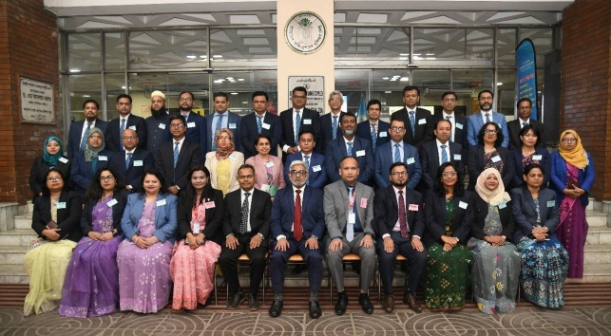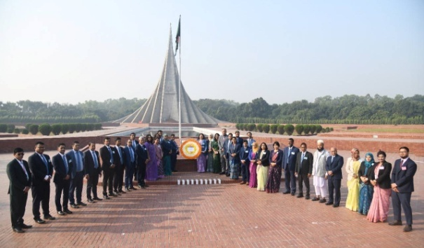
Ms. Sonia Nowrin, Project Director, GDRIDP, LGED onducted a session on 30th November about Electronic Government Procurement (E-GP) for the participants of 78th FTC.
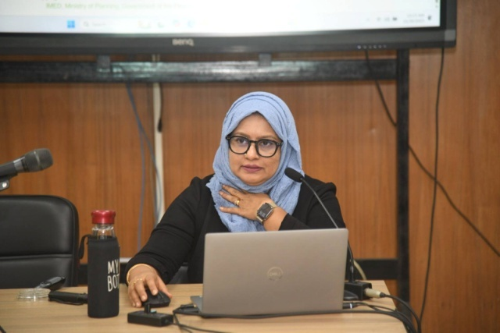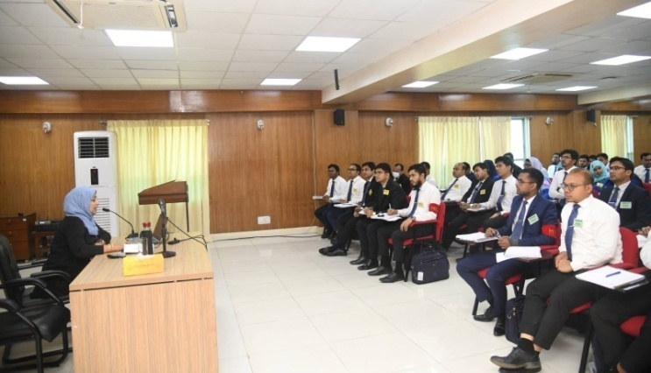

Certificate Awarding Ceremony of the 14th Special Foundation Training Course was held on 28th November 2025 at Mini Auditorium, ITC. Mr. Sayeed Mahbub Khan, Rector, BPATC was the Chief Guest and Mr. A S M Humayun Kabir, Director General (Additional Secretary), Election Commission Secretariat was Special Guest of the program.
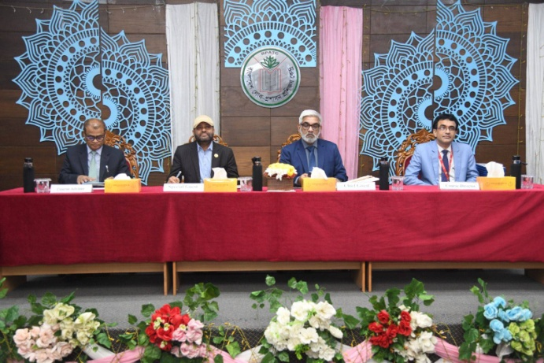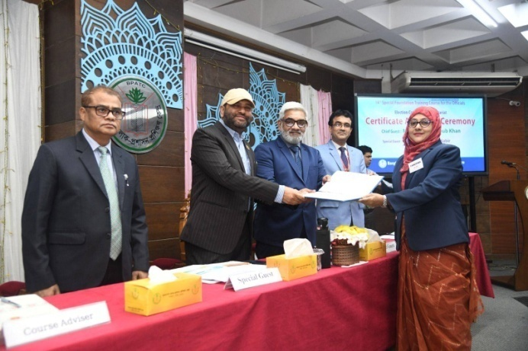
Cultural Programme of the 14th Special Foundation Training Course was held on 27th November 2025 at Mini Auditorium, ITC. Mr. Sayeed Mahbub Khan, Rector, BPATC was the Chief Guest of the event.
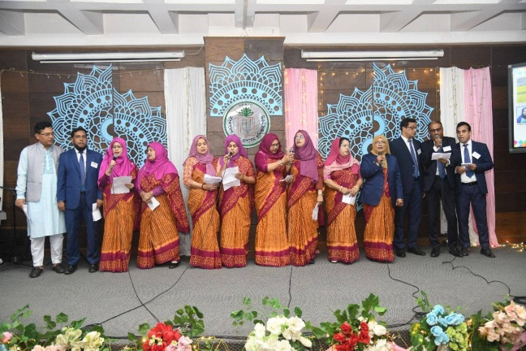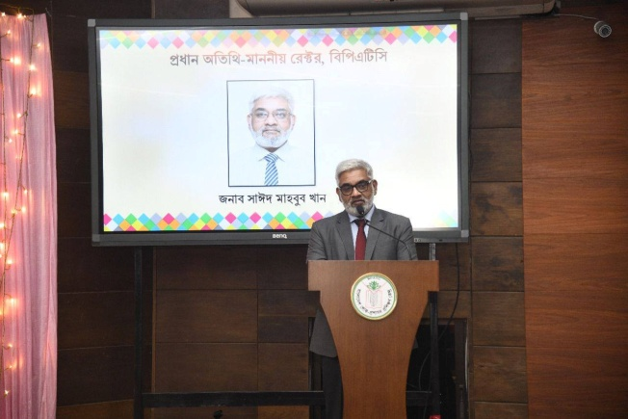
Justice (Retd.) Moyeenul Islam Chowdhury, Chairperson, The Commission on the Inquiry of the Enforced Disappearance conducted a two hour session on Human Rights in Bangladesh on 27th November 2025 for the participants of 78th FTC.

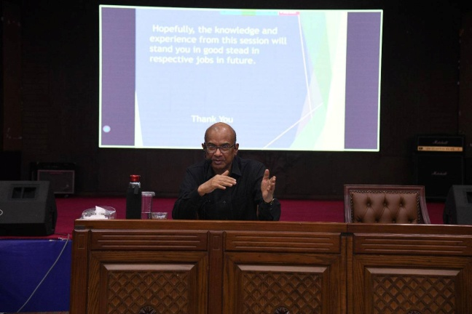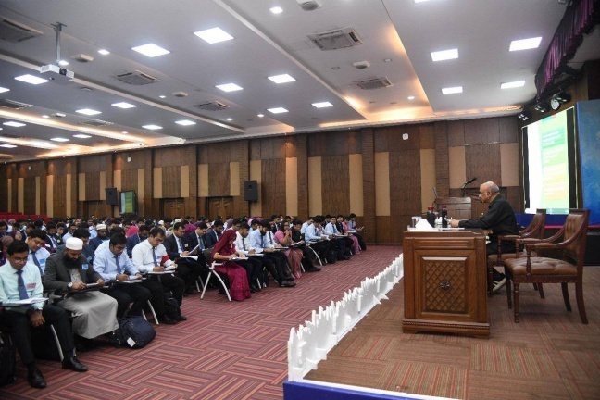

ThinkFest BPATC: Chapter One – Symposium on Green Ideas was held at BPATC on 26th November 2025. This program was organized by the environment committee of 78th FTC. Participants presented their Research posters on current issues of environment, climate change, agriculture etc. Dr. Mohammad Amir Hossain Bhuiyan, Professor, Department of Environmental Sciences, Jahangirnagar University and Sharmin Nahar Nipa, Coordinator, Centre for Climate Change and Environmental Research, Brac University evaluated the presented posters and selected top three posters. Finally, Mr. Sayeed Mahbub Khan, Rector, BPATC awarded prize among the winners of poster presentation and quiz competition.

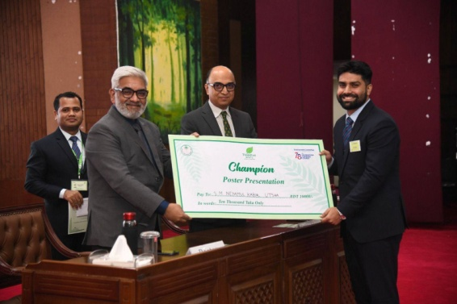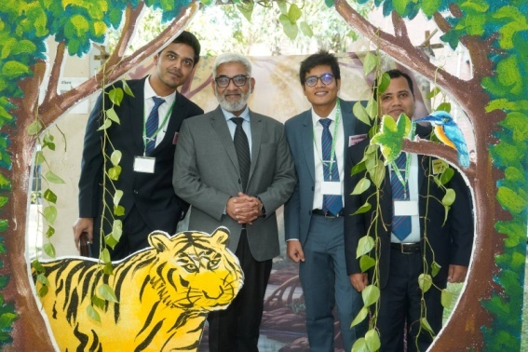

Mr. Anwar Hossain Chowdhury, Managing Director, SME Foundation conducted a Session on SMEs and Startup for Development for the participant of 14th Special Foundation Training Course for the officials of Bangladesh Election Commission Secretariat on 25th November 2025.
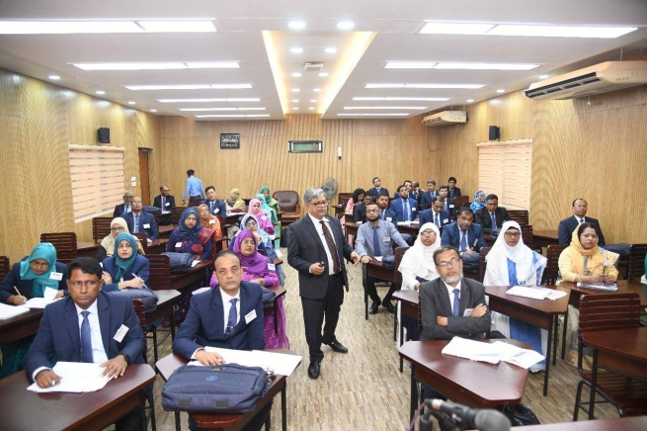
Barrister Md. Zillur Rahman, Additional Inspector General, Bangladesh Railway Police conducted a Session on Judiciary System in Bangladesh On 24th November 2025 for the participant of 1st Advanced Course on Professional Development (Bangladesh Bank).
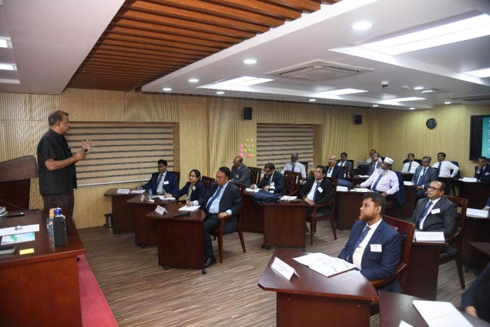
Prof. Dr. Syeda Shahina Subhan, Head of Biochemistry, Green Life Medical College, and Member, Board of Directors, BPATC conducted an insightful and interactive session on “Stress Management and Work-Life Harmony” for the participant of 1st Advanced Course on Professional Development (Bangladesh Bank).
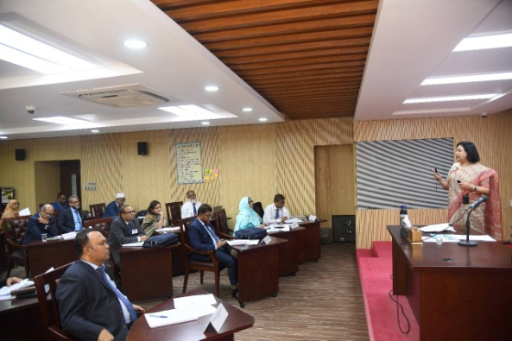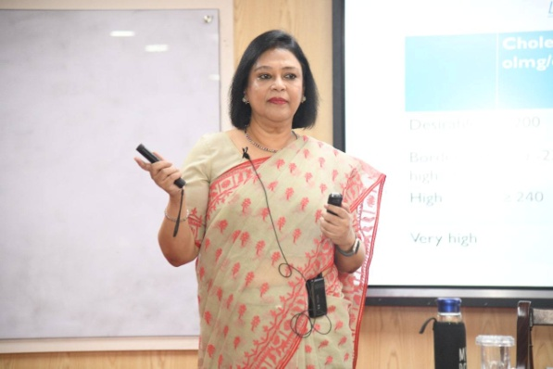
Mr. Hiroki Watanabe, Local Government Expert and Public Administration Advisor, JICA conducted a session on Session on Public Administration Reform and Development for the participant of 1st Advanced Course on Professional Development (Bangladesh Bank).
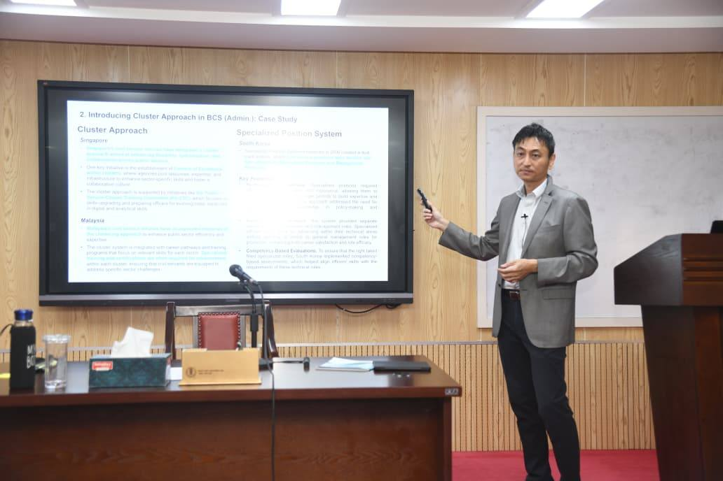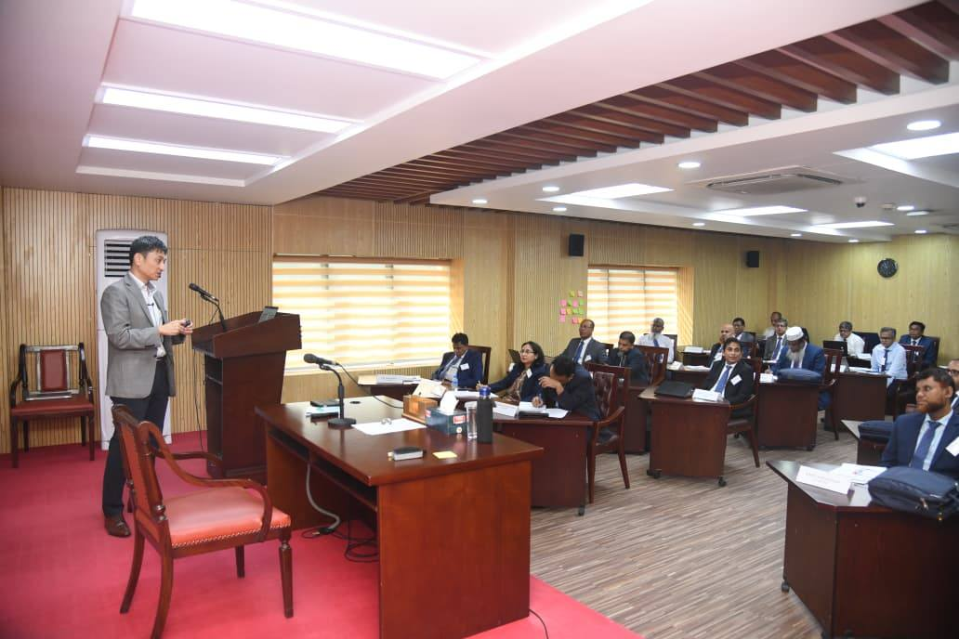

Dr. Debapriya Bhattacharya, Distinguished Fellow, CPD was led an insightful session on 23th November 2025 about Macroeconomic situation in Bangladesh: key issues and future outlook JICA for the participant of 1st Advanced Course on Professional Development (Bangladesh Bank).
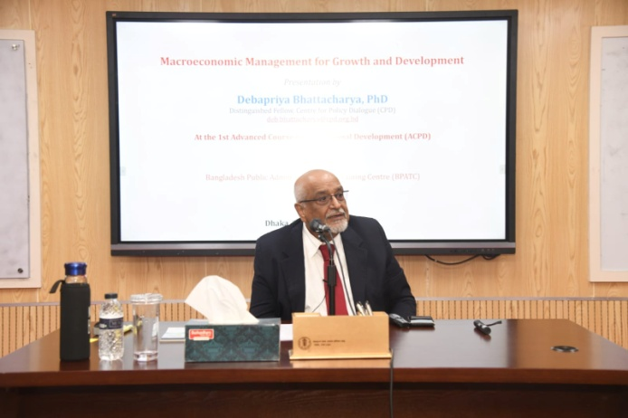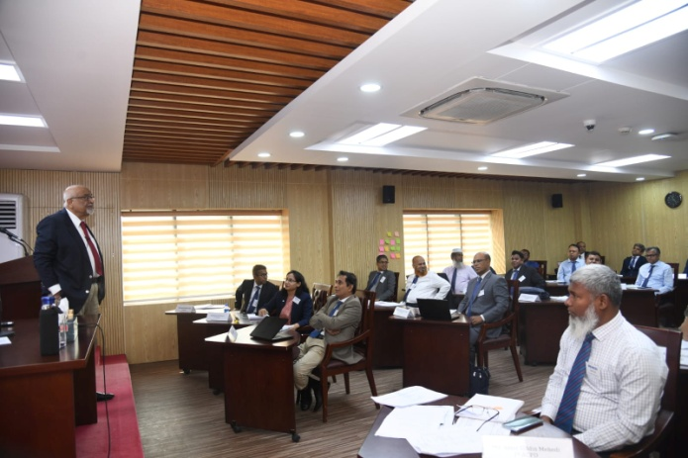
A full-day of institutional visit to JICA, Land Office, Business Automation Ltd, iBAS++, and Hawar IT, was organized by concerned CMT for Participants of the 1st Advanced Course on Policy Development (Bangladesh Bank) on 19 November 2025. Through this visit participants gained direct exposure to policy execution, financial governance, and technology-driven public service transformation.
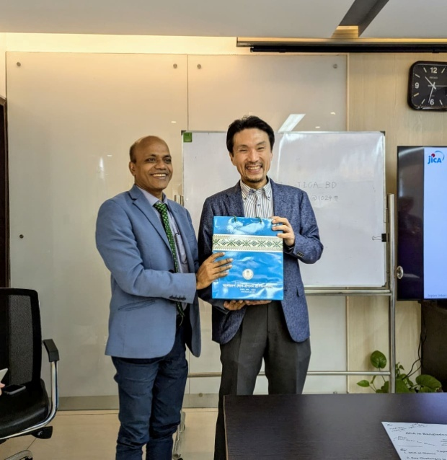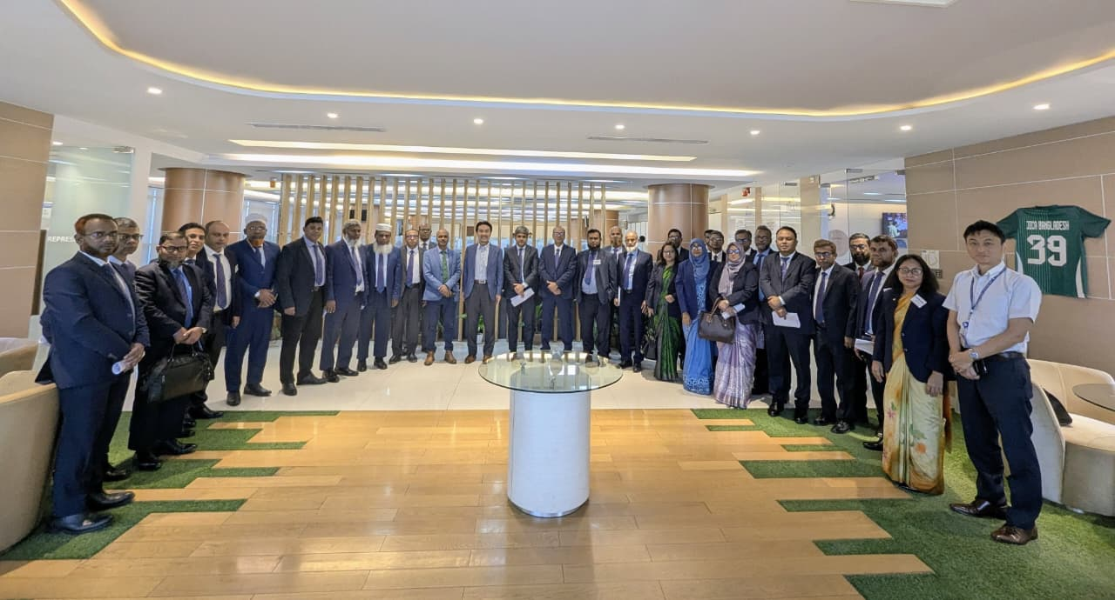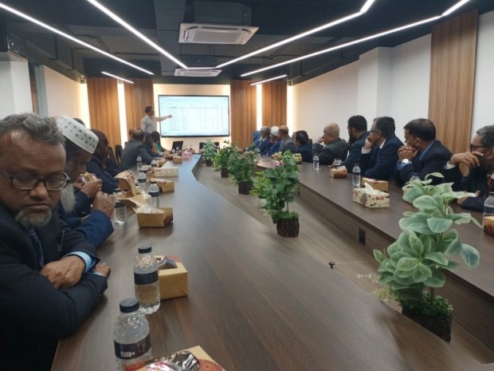
Mr. Ahmed Sharif (Chief Yoga Instructor), Mr. Sujit Baidya (Yoga Instructor) and Ms. Ferdaoushi Sultana (Yoga Instructor & Program Coordinator) conducted a thoughtful session on 20th November 2025 on “Yoga & Meditation Session: A Reflective Practice for Holistic Well-being” for the 120th SSC participants.
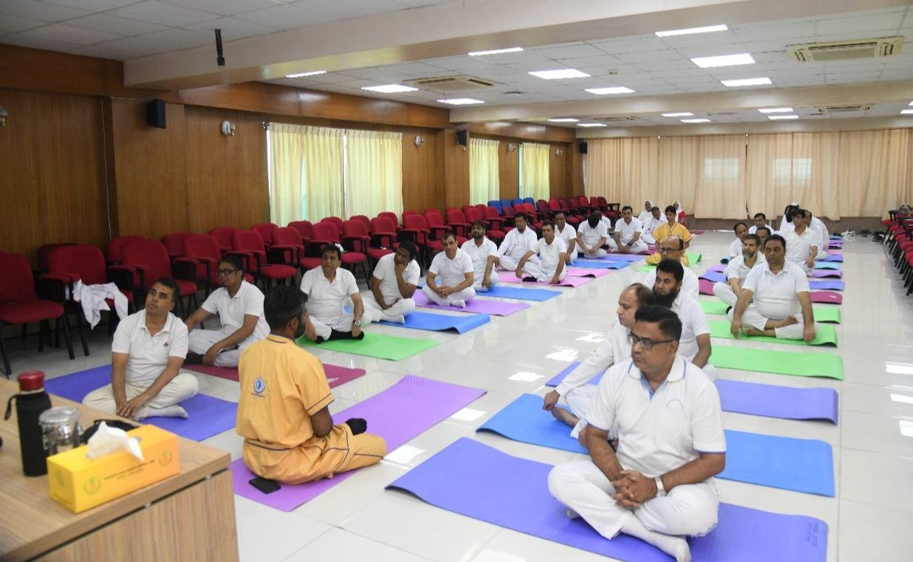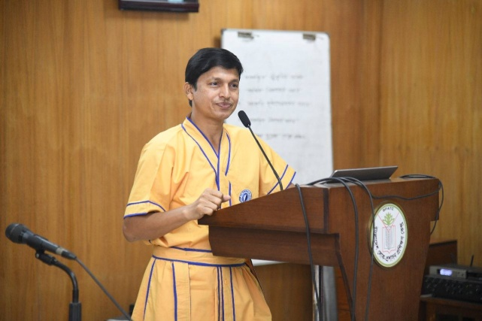

Certificate Awarding Ceremony of the 13th Special Foundation Training Course was held on 20th November 2025 at Bangladesh Public Administration Training Centre (BPATC). The event was graced by Mr. Sayeed Mahbub Khan, Rector, BPATC, as the Chief Guest. Mr. A S M Humayun Kabir, (Additional Secretary) Director General of ECS, attended the program as the Special Guest.
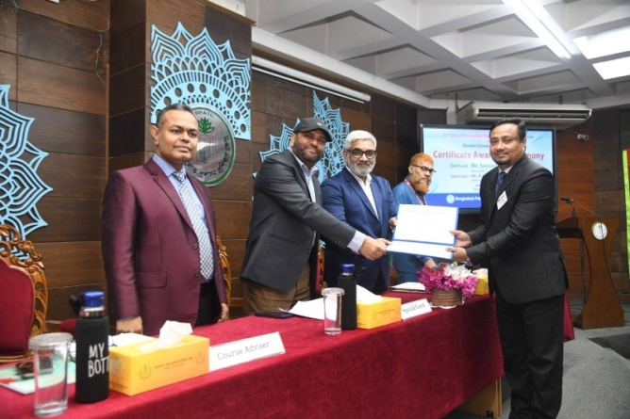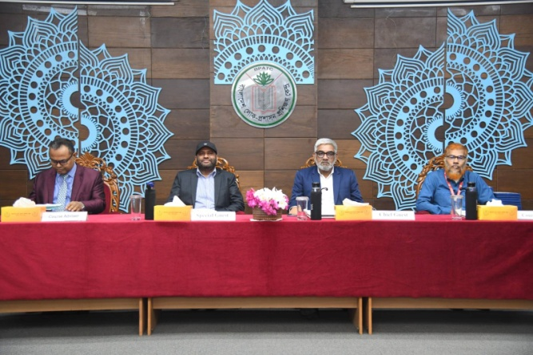
Prof. Dr. Sunjida Shahariah, Member Secretary, Palliative Care Society of Bangladesh, Executive Editor, Biomedical Journal & Palliative Care Journal conducted a highly insightful session on “Mental Health & Wellness Approaches” for the participants of the 1st ACPD (Bangladesh Bank) at the Bangladesh Public Administration Training Centre (BPATC).
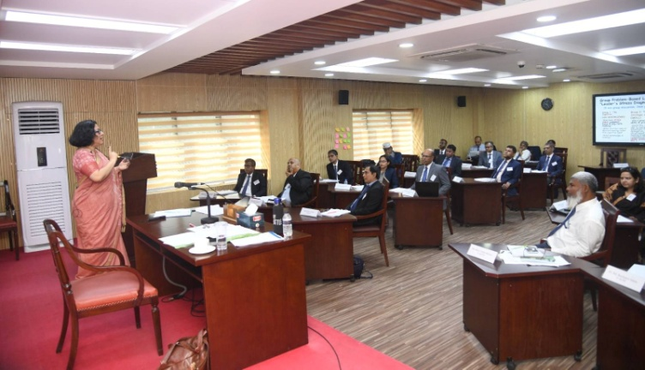
A vibrant Cultural Evening & Guest Night was held at the Mini Auditorium of BPATC on 19th November 2025 as part of the 13th Special Foundation Training Course (Election Commission Secretariat – ECS). The event was graced by Mr. Sayeed Mahbub Khan, Rector, BPATC, as the Chief Guest.
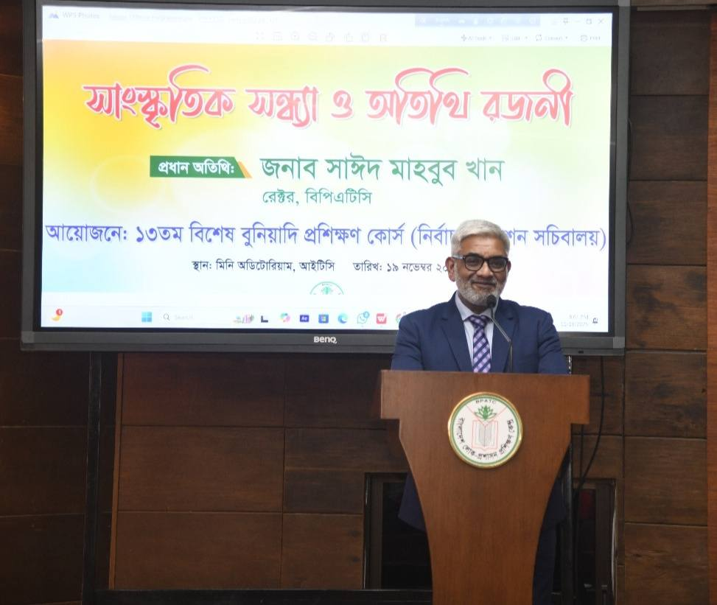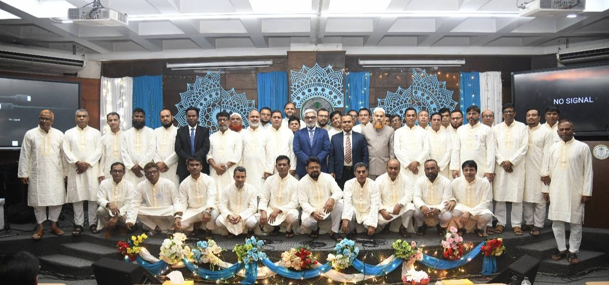
The Certificate of Participation Awarding Ceremony of the 154th ACAD course was held at the Bangladesh Public Administration Training Centre on 19th November, 2025. Mr. Sayeed Mahbub Khan, Rector of BPATC was acted as Chief Guest of the program.
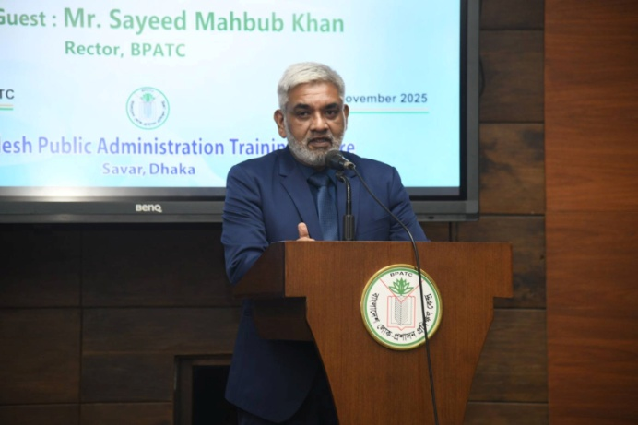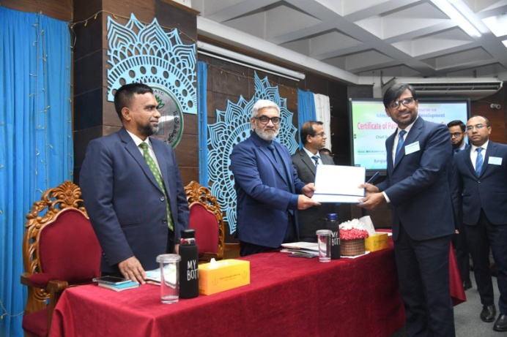
Mr. Zakaria, Chairman & Additional Secretary, Bangladesh Food Safety Authority, delivered an insightful session on “Food Safety Initiatives in Bangladesh: Challenges & Progress” for the participants of the 78th Foundation Training Course (FTC).
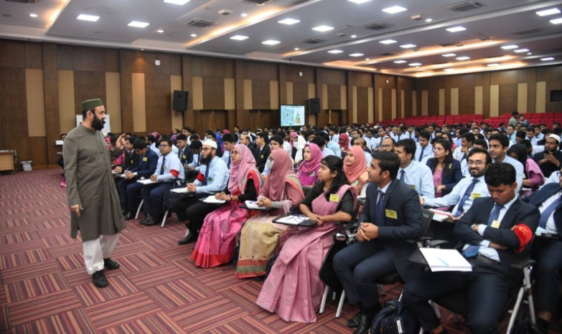
A special session titled “Policy Formulation & Evaluation Exercise” was conducted by Dr. Rizwan Khair, Former MDS, BPATC and Mohammad Rezaul Karim PhD, Deputy Director, BPATC for the participants of the 120th Senior Staff Course at the Centre.
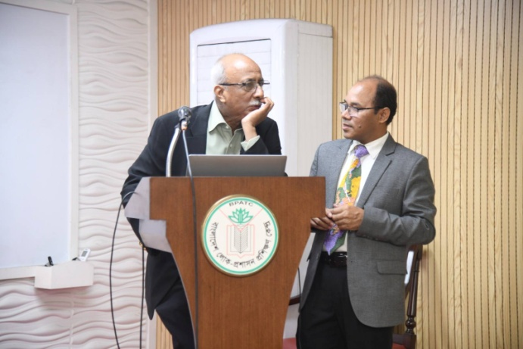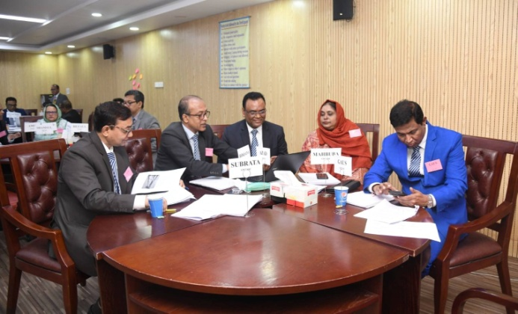
Cultural Programme and Guest Night was organized at the Bangladesh Public Administration Training Centre for the participants of the 154th Advanced Course on Administration and Development (ACAD) on 19th November. Participants perform solo and duet music, group presentations, recitation, and stage acting.
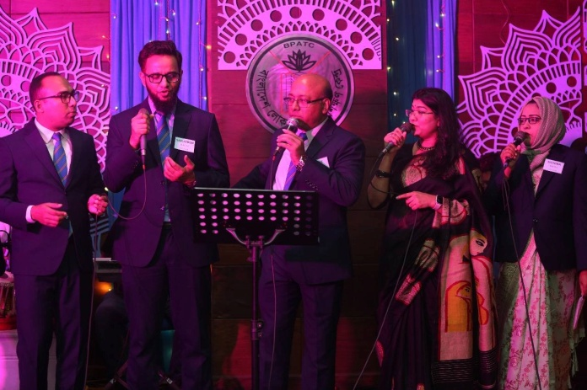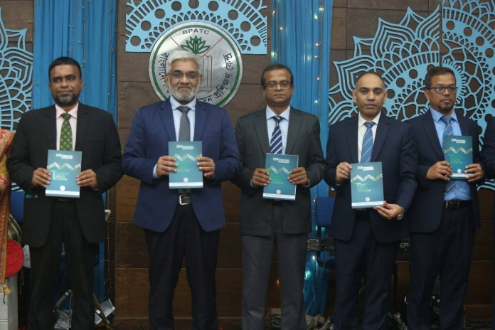
Professor Ainun Nishat, Professor Emeritus, BRAC University conducted an insightful session for the participants of the 120th SSC Course on 18th November 2025. He focused on “Climate Change, Justice & Development: Imperatives for Mitigation & Adaptation.”
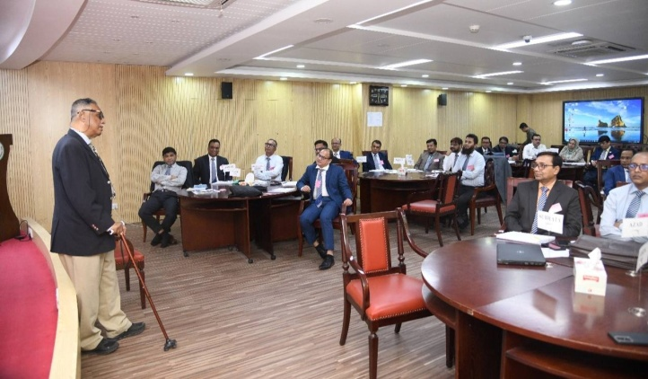
Fresher Reception 2025 was held at BPATC School and College on 18th November 2025. Mr. Sayeed Mahbub Khan, Rector of BPATC and Chairman Governing body, BPATC School and College was present at the program as a Chief Guest.
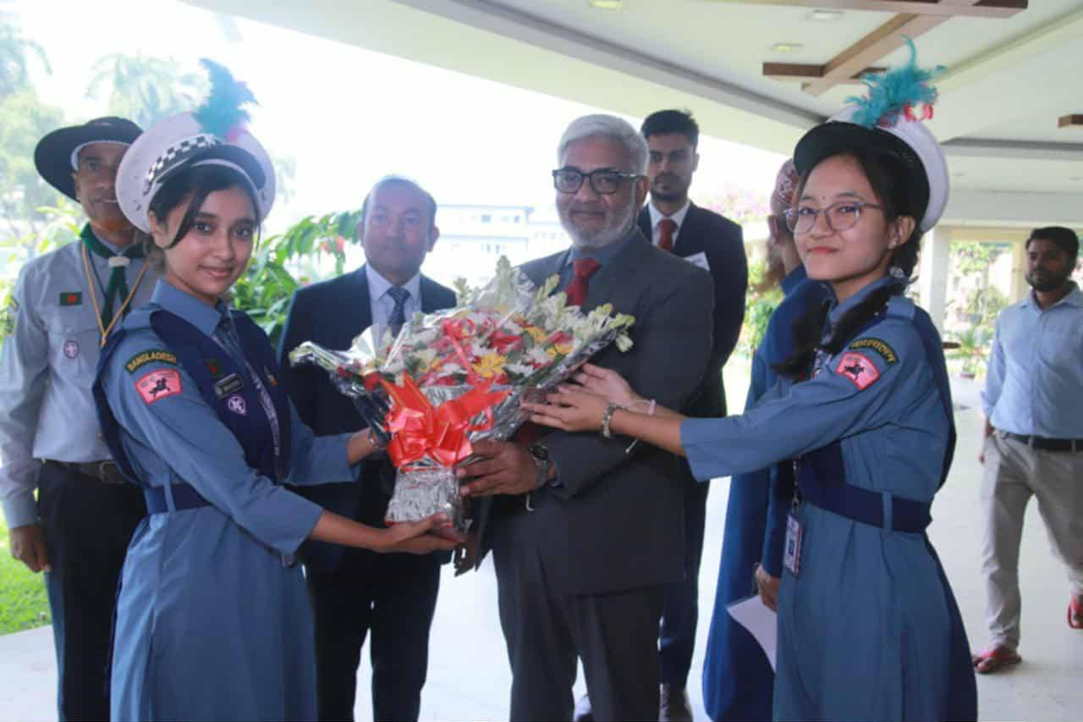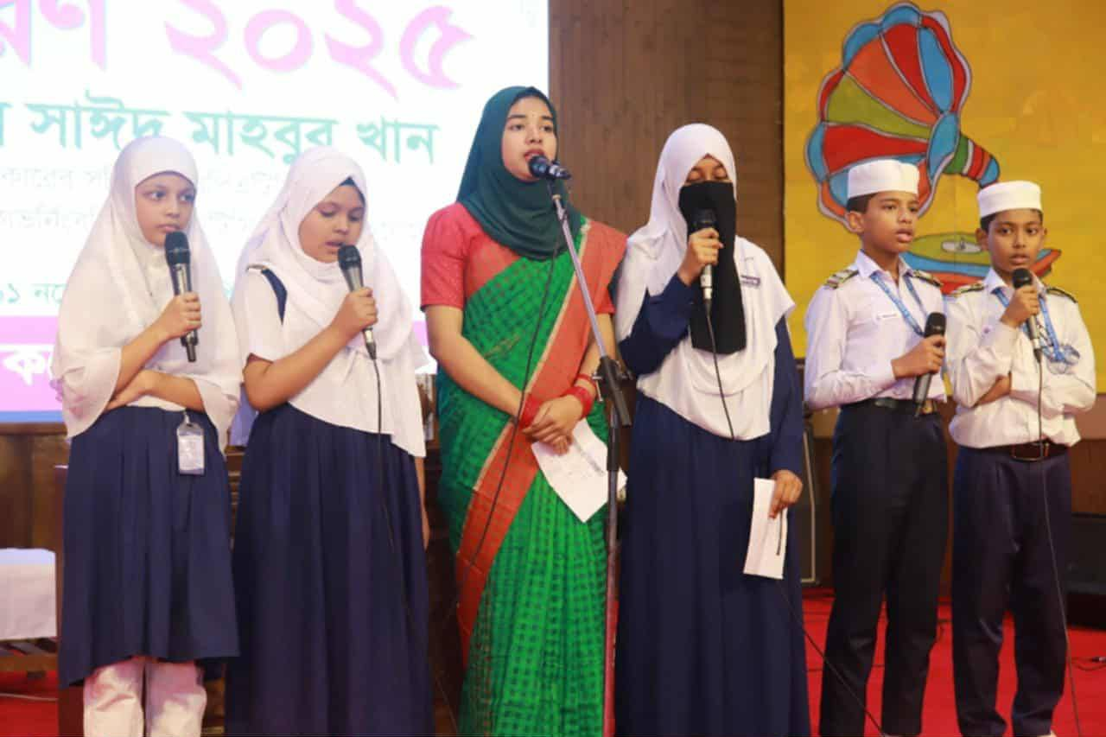
Dr. Syed Md. Saikh Imtiaz, Professor, Department of Women & Gender Studies, led an eventful session on 18 November 2025 on “Human Rights, Gender & Social Justice: Key Issues” for the participants of the 78th Foundation Training Course.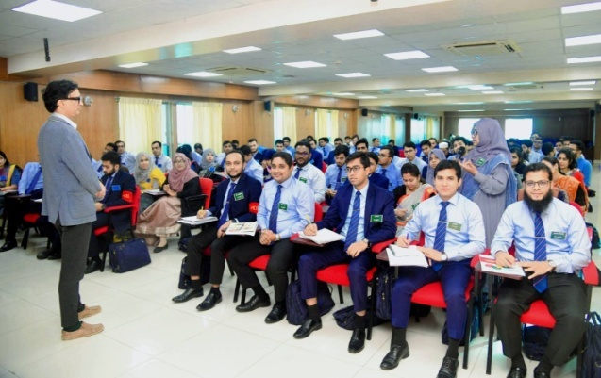
Dr. Abdur Rahim, Joint Secretary and Program Executive & Coordinator (PEC), Finance Division, was present at BPATC on 17 November and conducted a comprehensive session on “National Budgeting & Public Financial Management in Bangladesh” for the participants of the 1st ACPD – Bangladesh Bank.
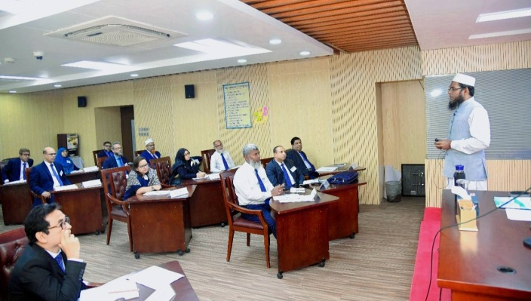
The Seminar Paper Presentation Session of the 154th ACAD was conducted by Mr. Md. Abdul Khaleque, Secretary, Ministry of Chittagong Hill Tracts Affairs, and Mr. Md. Atikuzzaman, MDS, BPATC, on 17 November 2025.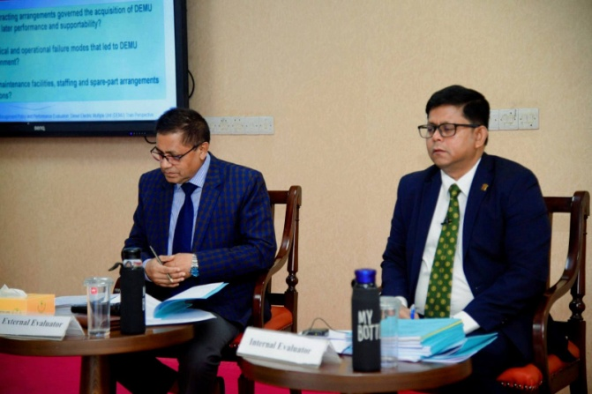 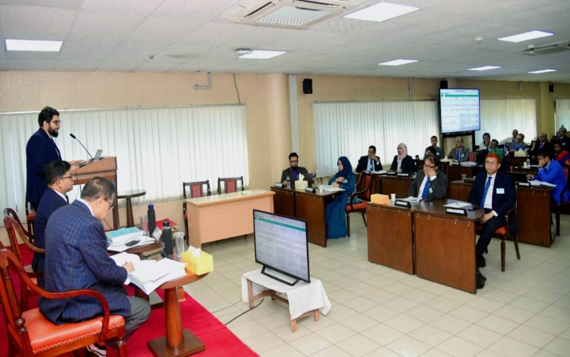
Mr. Md. Aknur Rahman, PhD, Joint Secretary, Energy & Mineral Resources Division, delivered an insightful discussion on “Tender Opening & Evaluation, Approval & Awarding,” on 16 November explaining each component of the public procurement cycle in a structured and practical manner for the participants of the 13th SFTC (ECS).
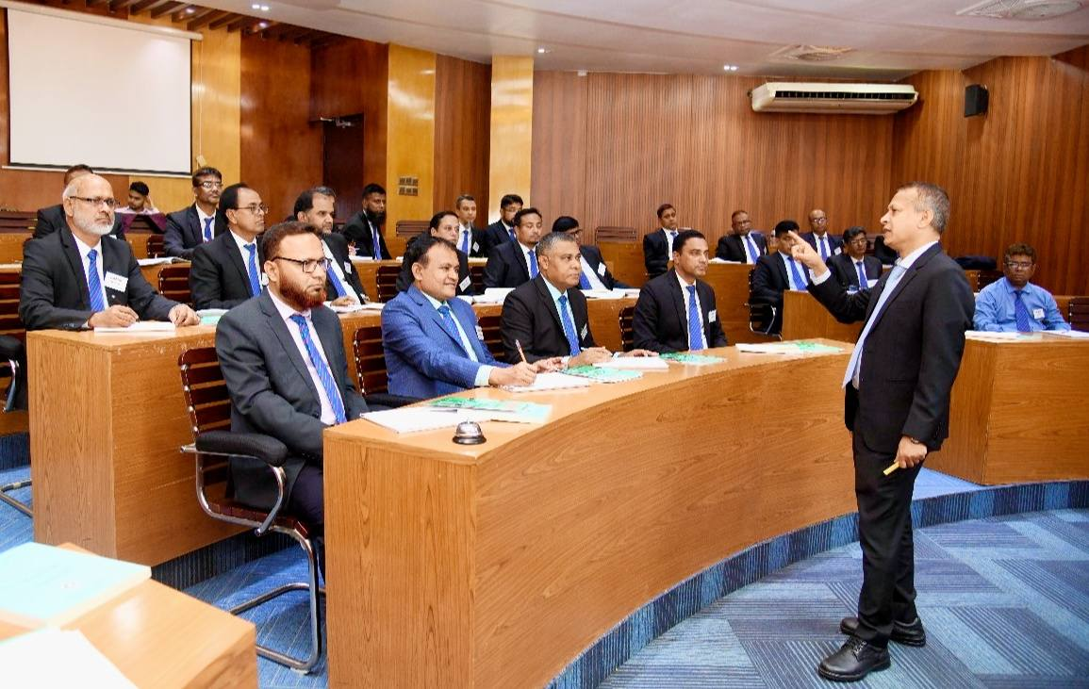
Dr. Md. Maruf Nawaz, Director (Training Program), National Institute of Mass Communication (NIMC) conducted a session on “Media Relations” for the participants of the 14th SFTC (Election Commission Secretariat) on 16th November 2025.
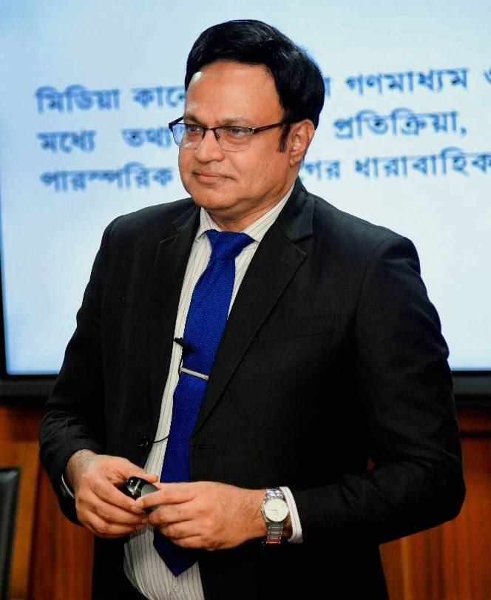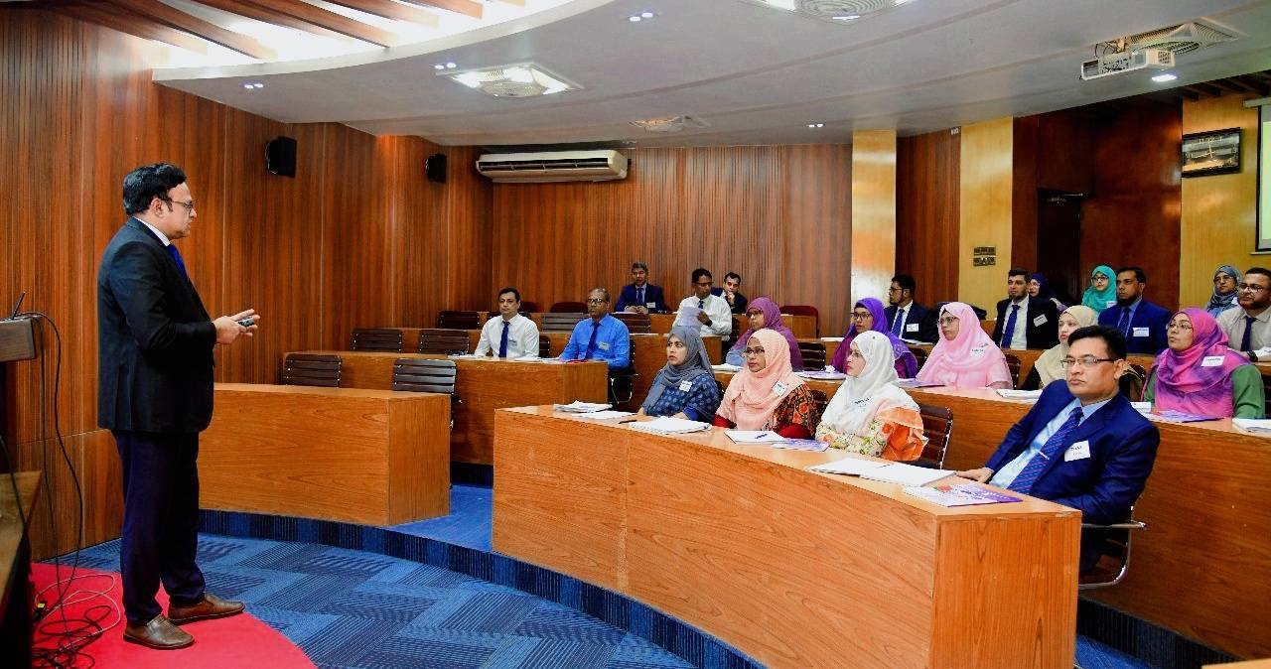
Dr. Mst. Sheren Shobnom, Deputy Secretary, Ministry of Finance conducted an insightful session on IBAS++ platform for the participant of the 13th SFTC (ECS – Election Commission Secretariat).
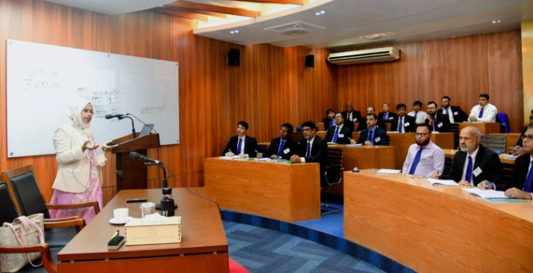
Fishing at BPATC Lake
BPATC organized a festive fishing event at the its lake using the traditional hook and wheel (borshi) method on November 15, 2025. The event was inaugurated by Mr. Sayeed Mahbub Khan, Rector, BPATC. It was a festive occasion where faculty members and staff participated with their families, shared happiness and enjoyed fishing from 7:00 am to 5:00 pm.
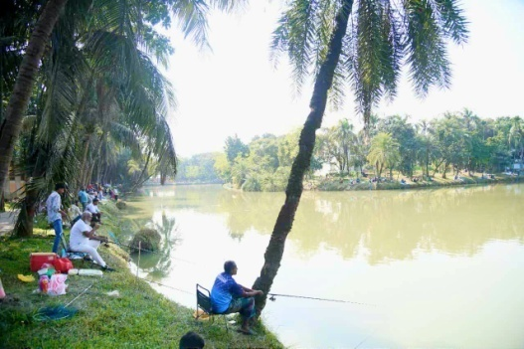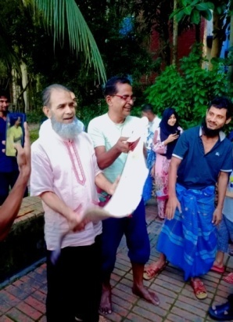
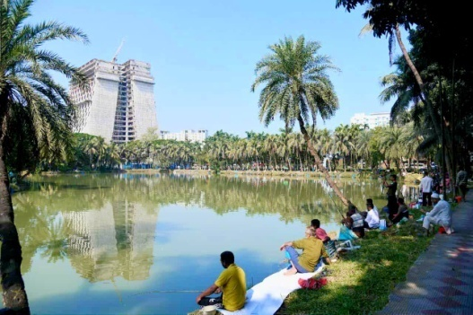

Cultural Gala of 78th FTC: Symphony of Resonance
The participants of the 78th Foundation Training Course (FTC) presented a vibrant cultural gala titled “Symphony of Resonance” on November 5, 2025. The performance was held in the evening at the BPATC auditorium followed by a grand dinner.
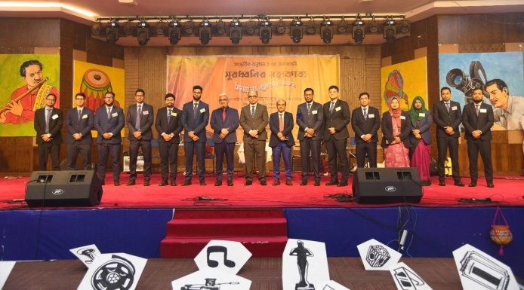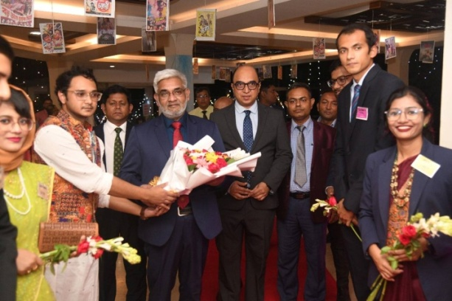
Inaugurations and Certificate distribution ceremonies
The inaugural ceremony for the 120th Senior Staff Course (SSC) took place on November 9 at the ITC Auditorium. The event was graced by Mr. Sayeed Mahbub Khan, Rector, BPATC, who attended as the Chief Guest.
1st Advanced Course on Professional Development (ACPD) for Bangladesh Bank officials commenced at BPATC on November 9. Mr. Sayeed Mahbub Khan, Rector, BPATC, served as the Chief Guest, while Mr. Md. Hanif Miah, Executive Director of Bangladesh Bank, attended as the Special Guest.
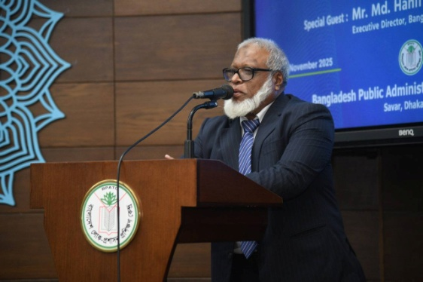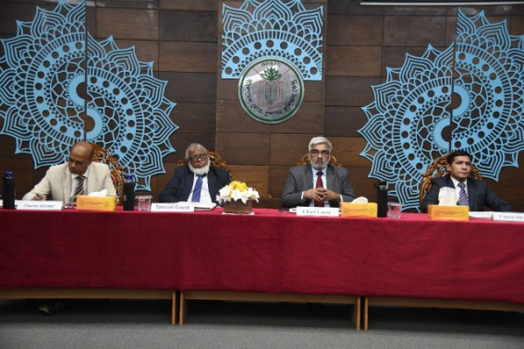
Closing ceremony of 28th Policy Planning and Management Course (PPMC)
The Certificate of Participation Awarding Ceremony for the 28th PPMC was held on November 6 at the Mini Auditorium, ITC Building. The ceremony was chaired by Mr. Sayeed Mahbub Khan, Rector, BPATC.
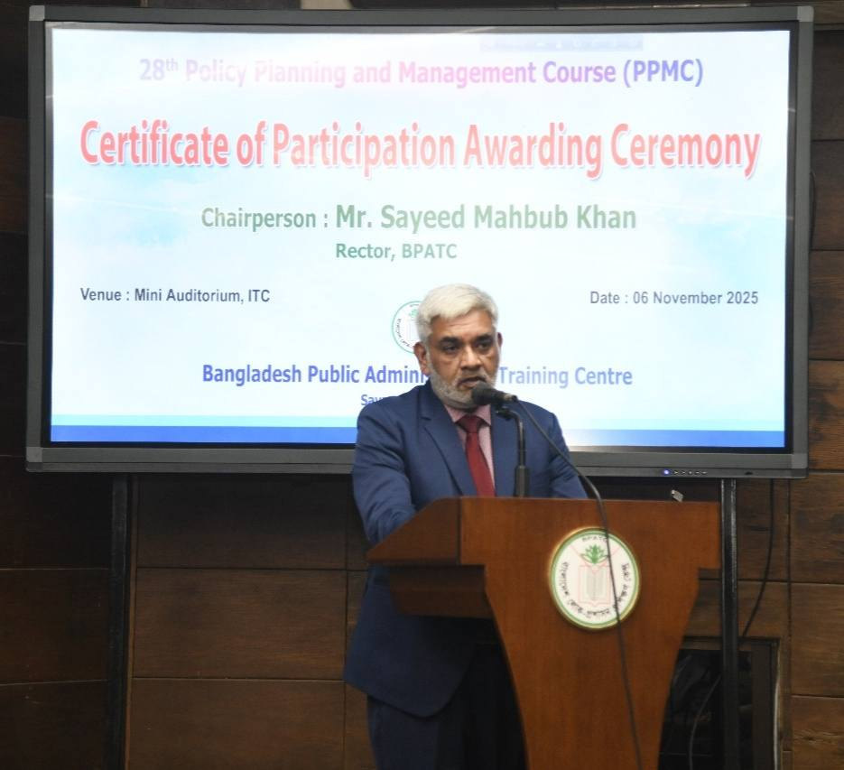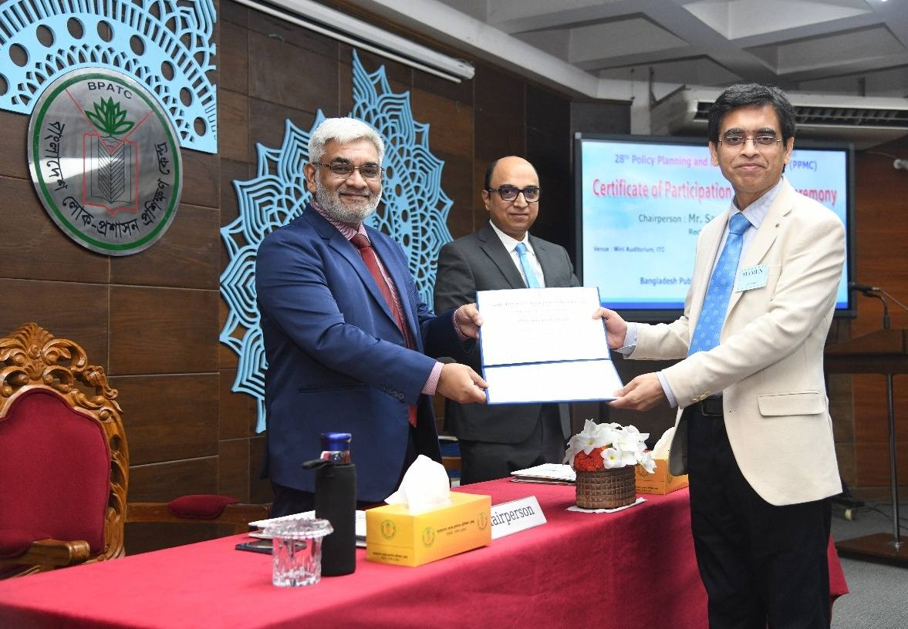
Seminars and Sessions conducted at BPATC
Seminar on the 4th Industrial Revolution
A thought-provoking seminar titled “4th Industrial Revolution and Transformation of Public Service” was held on November 2 for the 28th PPMC participants. The keynote address was delivered by Mr. Muhammad Hiruzzaman, ndc, Director General of the National Institute of Mass Communication (NIMC). The session was further enriched by discussions from Mr. Md. Mamunur Rashid Bhuiyan, Additional Secretary, ICT Division, and Dr. Md. Sazzadur Rahman, Professor, IIT, Jahangirnagar University.
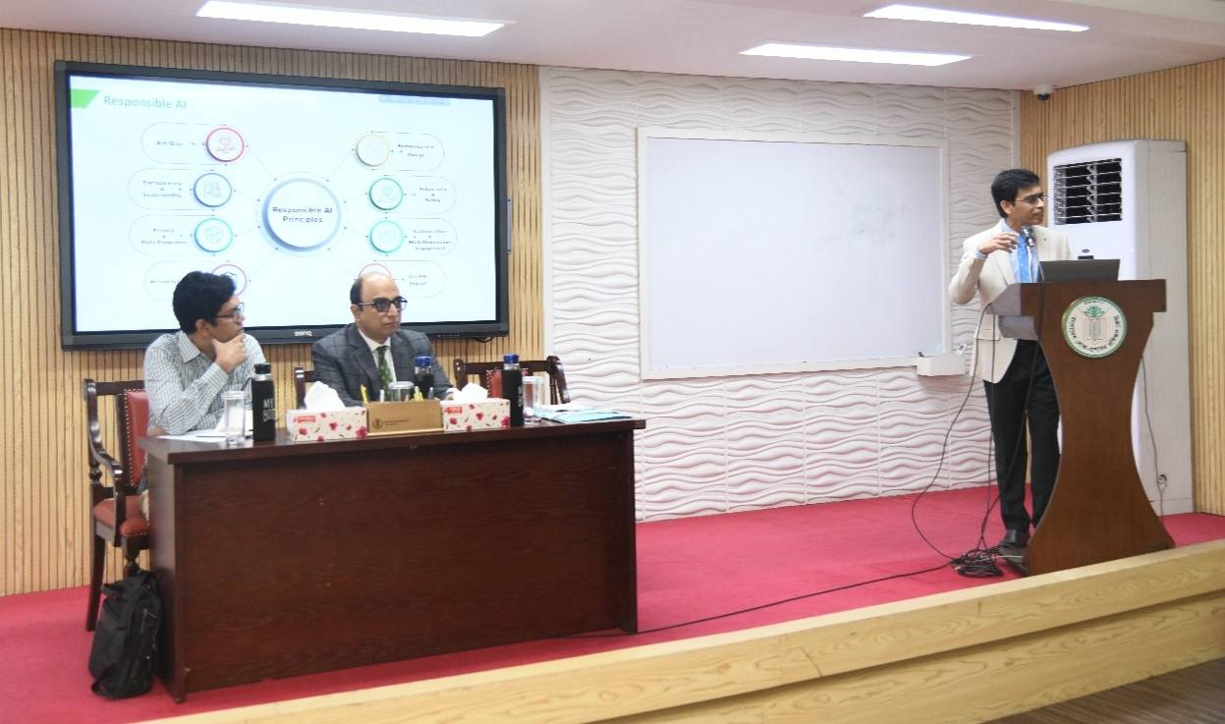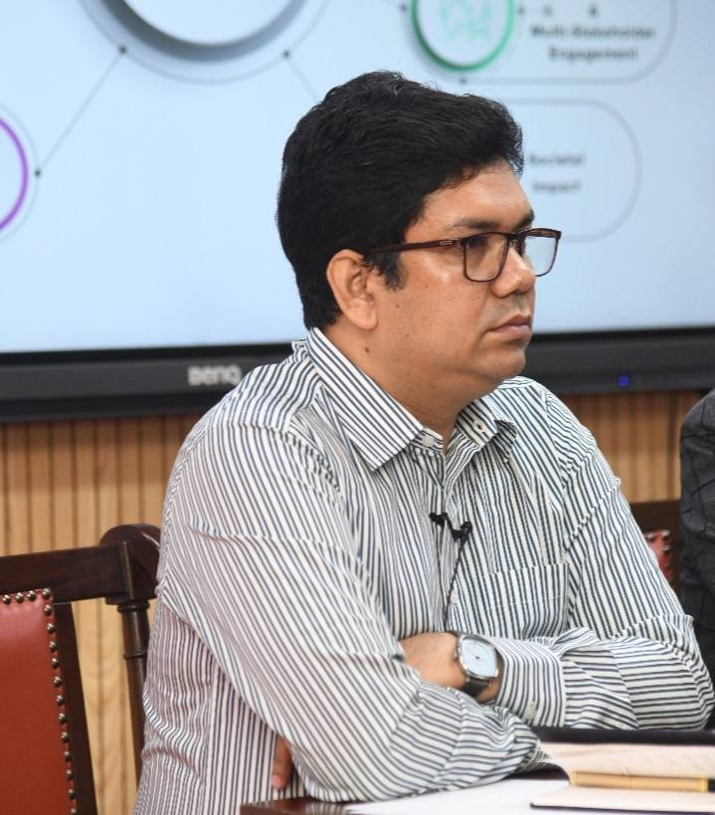
Session on Digital Transformation and Governance
Mr. Shish Haider Chowdhury, ndc, MCIPS, Secretary of the Information and Communication Technology (ITC) Division, conducted a session on “Digital Transformation of Government: Leveraging AI for Anticipatory Governance” for the 28th PPMC.
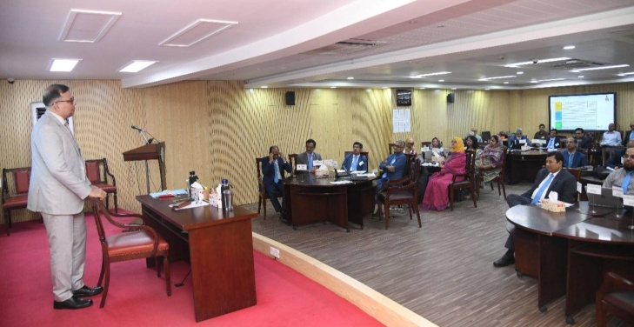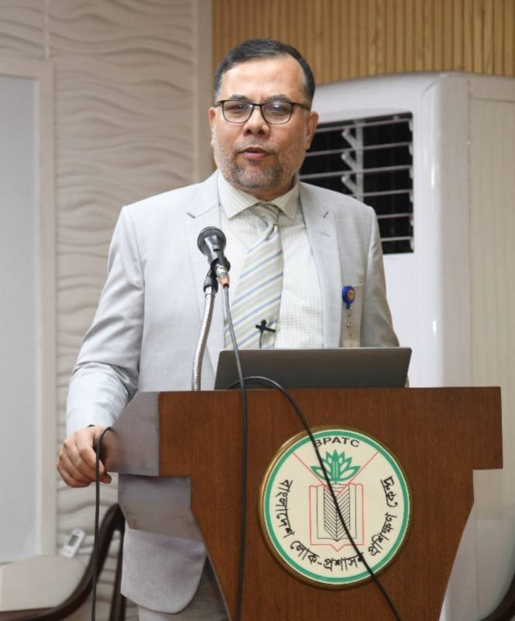
Session on Whole-of-Government Approach
In a session for the 120th SSC, Dr. Md. Humayun Kabir, Additional Secretary (Reforms), Cabinet Division, discussed the “Whole-of-Government Approach towards Policy Making,” with special reference to inter-ministerial meetings and stakeholder consultations on that day.
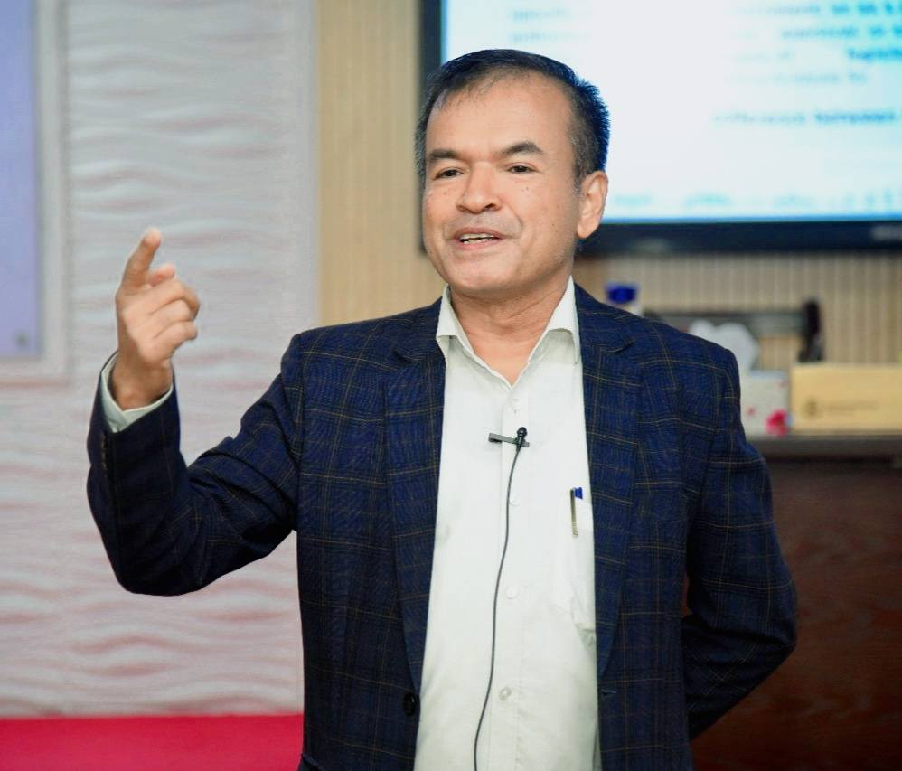
Ms. Zaheda Parveen, Secretary (Coordination & Reforms), Cabinet Division, led a special session for the 78th FTC titled “Breaking Silos: Whole-of-Government Approach for Effective Public Service”.
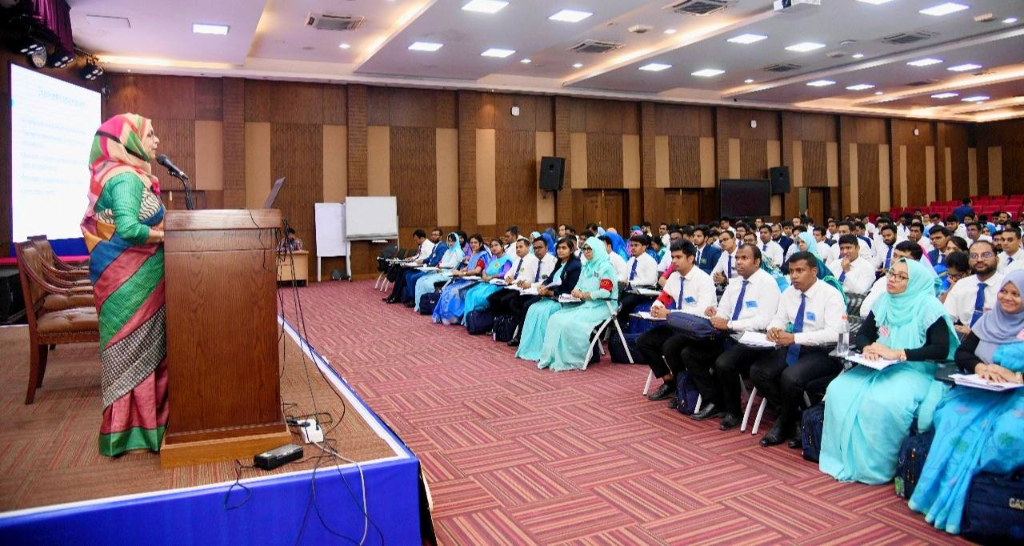
Dr. Nabila Idris, Member of the Commission on Enquiry on Enforced Disappearances in Bangladesh, conducted an engaging session on Bangladesh’s Accession to the UN Convention on Enforced Disappearances: Policy Implications for Human Rights Governance” for the 154th ACAD Course on 2 November 2025.
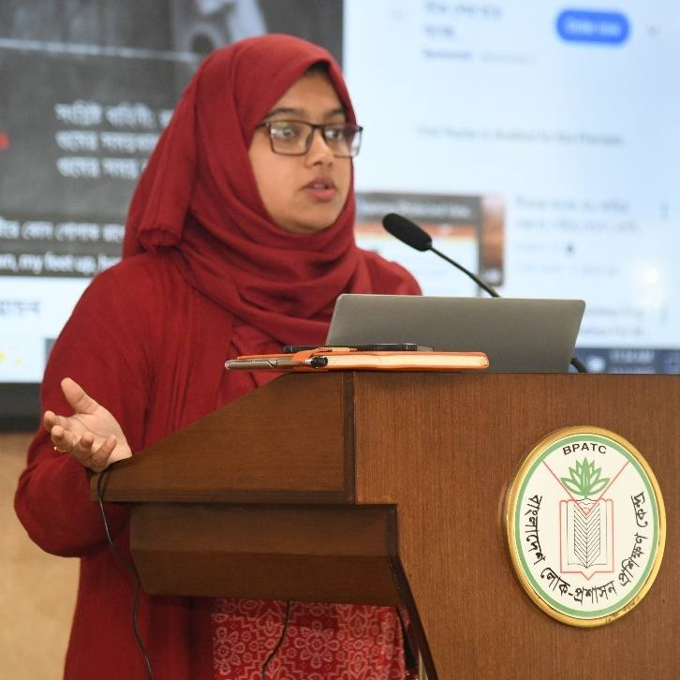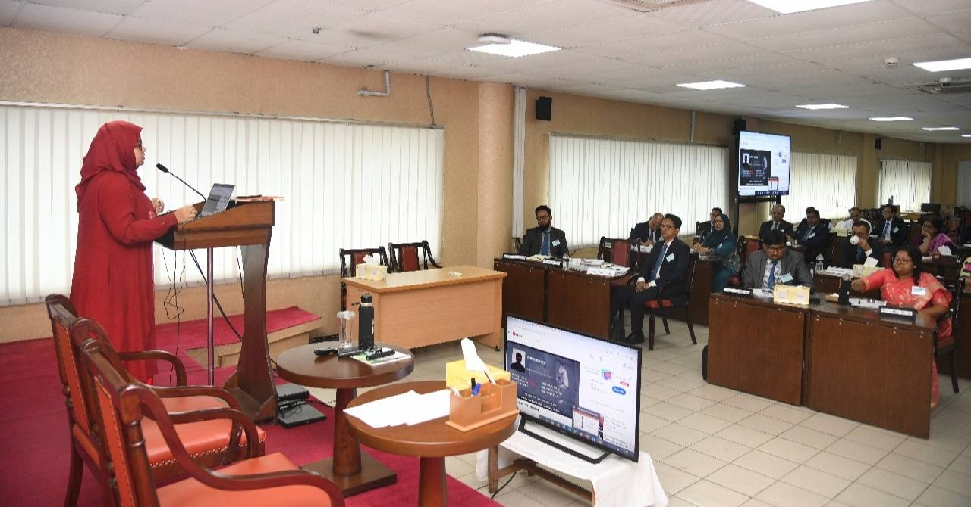
Mr. Md. Khademul Karim Iqbal, Chief Accounts and Finance Officer (CAFO), Ministry of Public Administration, conducted a session on the “Auditing System in Bangladesh and Disposal Process of Audit Objection” for the 78th FTC on November 12.
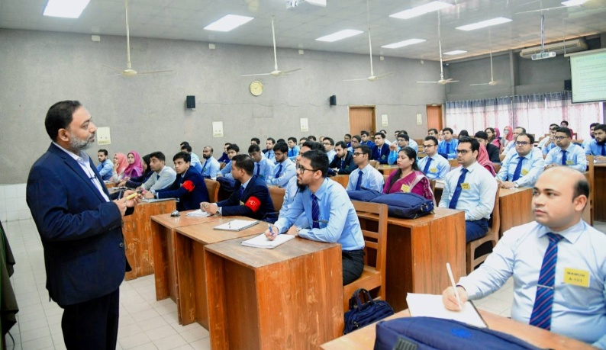
Ms. Umme Nahida Akter, Deputy Commissioner of Customs and VAT, NBR, conducted a session on “Laws and Practice of VAT” on November 11 for the 78th FTC.
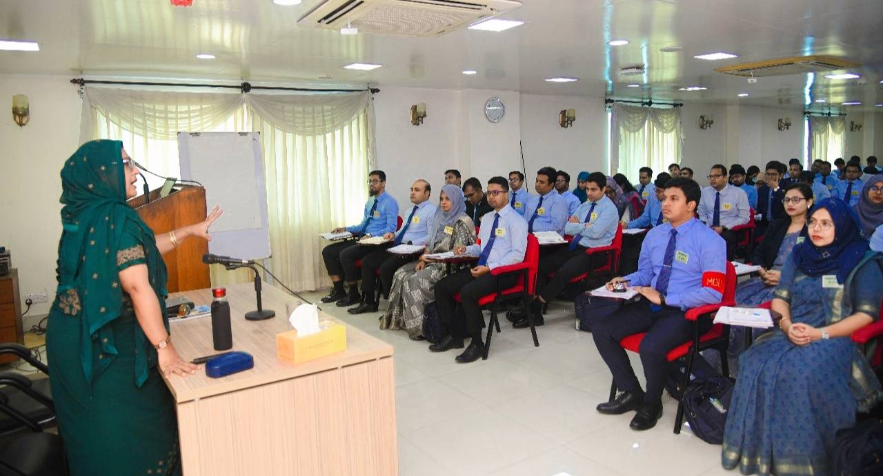
Dr. Moniruzzaman, Coordinator & Expert in Lifestyle Modification, Quantum Heart Club, Quantum Foundation was conducted a special session on “Scientific Lifestyle and Food Habit” for the participants of the 120th Senior Staff Course (SSC) on 12th November 2025.

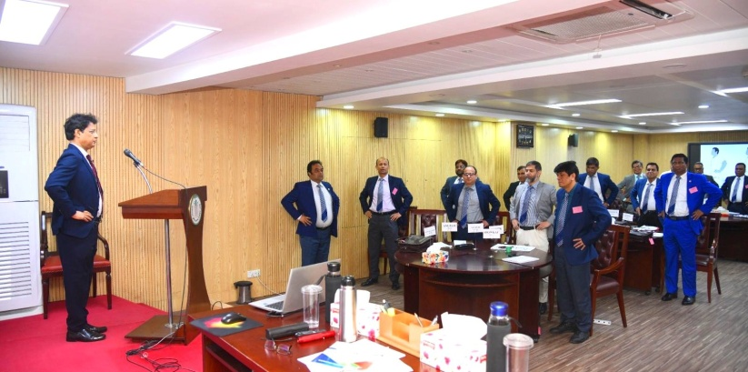
Dr. Asif Iqbal, Deputy Secretary, Financial Sector Reforms, Ministry of Finance, conducted a session on “Monetary Policy and Fiscal Policy: Dimensions and Implications” for the 13th and 14th SFTC (ECS) courses.
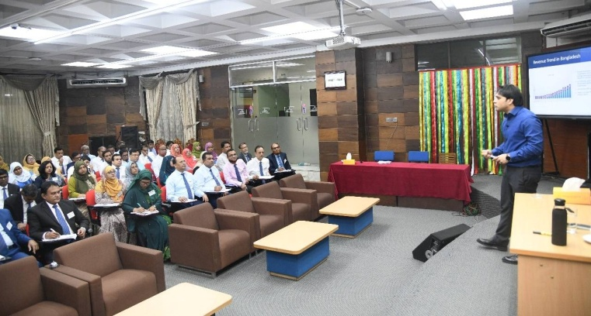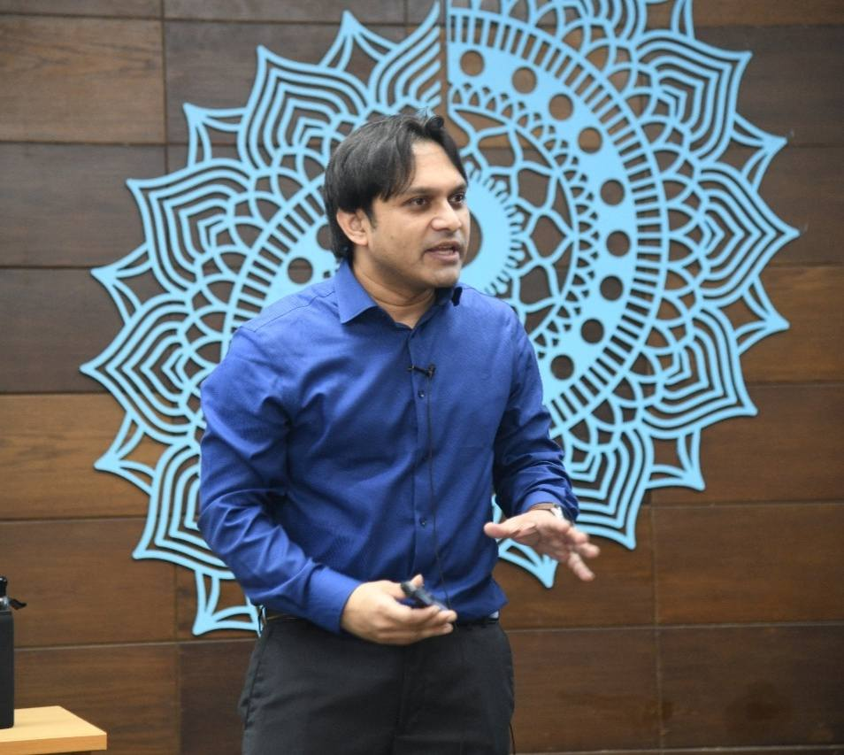
Dr. Mohammed Amjed Hossain, Joint Secretary, Power Division, delivered comprehensive sessions on General Financial Rules and Treasury Rules for the 78th FTC.
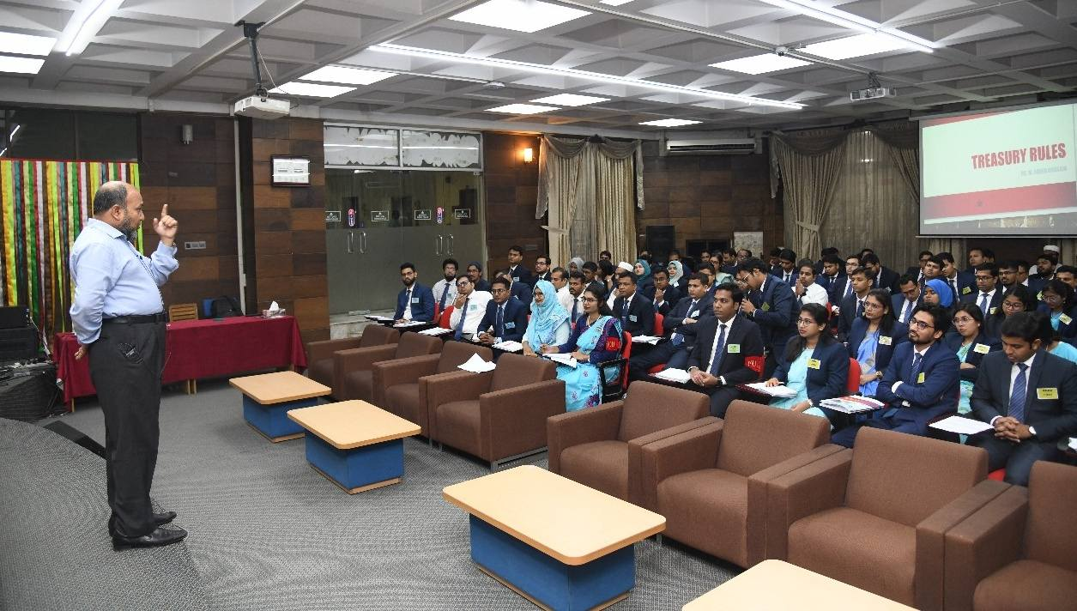
Mr. Md. Nurul Islam, DG, Foreign Aided Projects Audit Directorate, conducted a session on “Audit Objections and its Disposal Procedure” for the 14th SFTC (ECS).
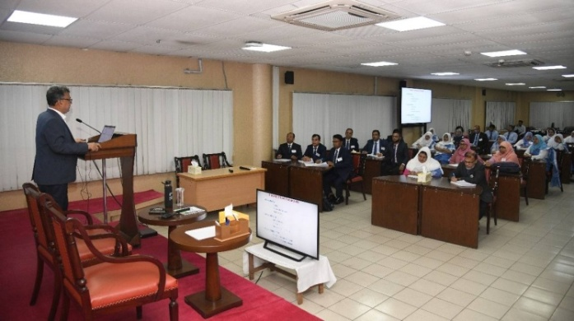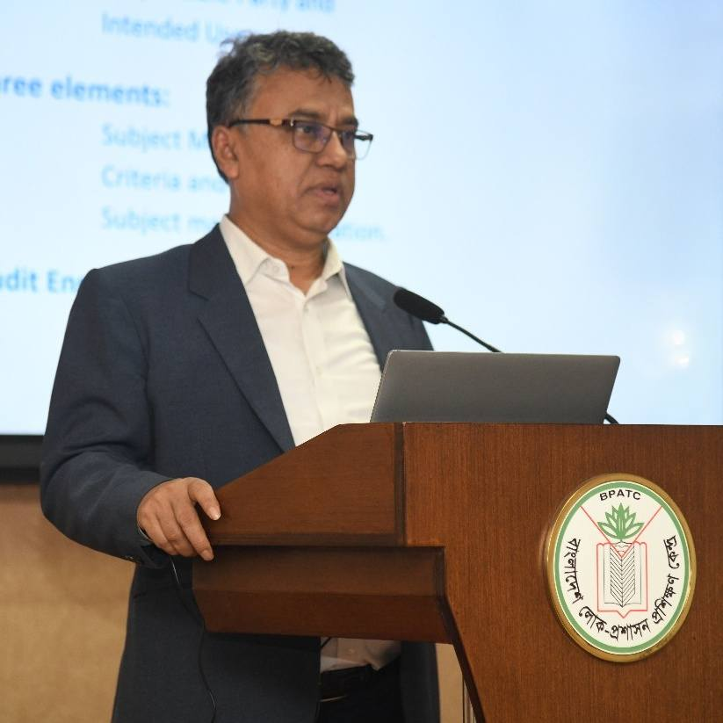
Mr. Md. Ashrafuzzaman, Additional Secretary, Physical Infrastructure Division, delivered an insightful session for the 78th FTC on the “Overview of Project Planning and Approval Process in Bangladesh” on 13 November 2025.
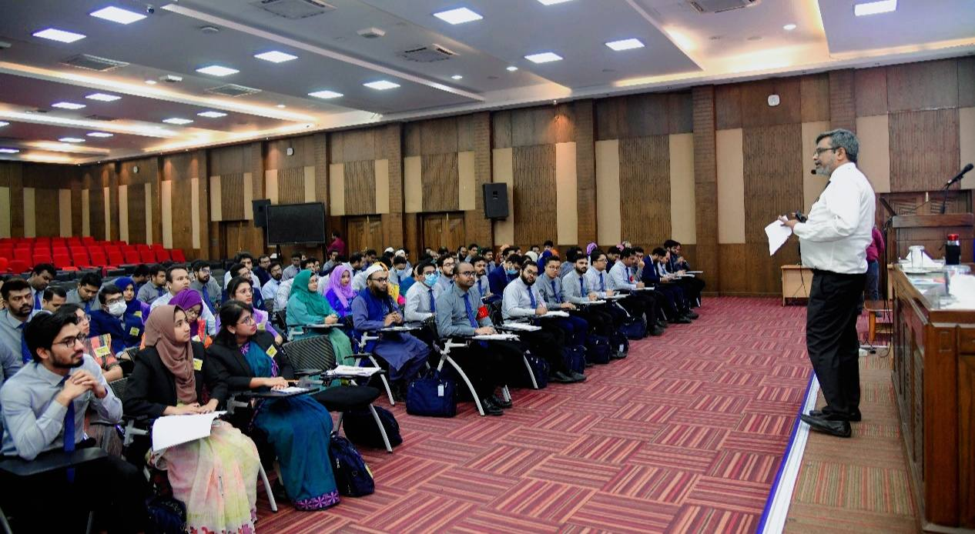
Dr. Najmus Sayadat, Joint Secretary, PPP, Finance Division, conducted a session on “Public Private Partnership (PPP)” for the 13th & 14th SFTC (ECS).
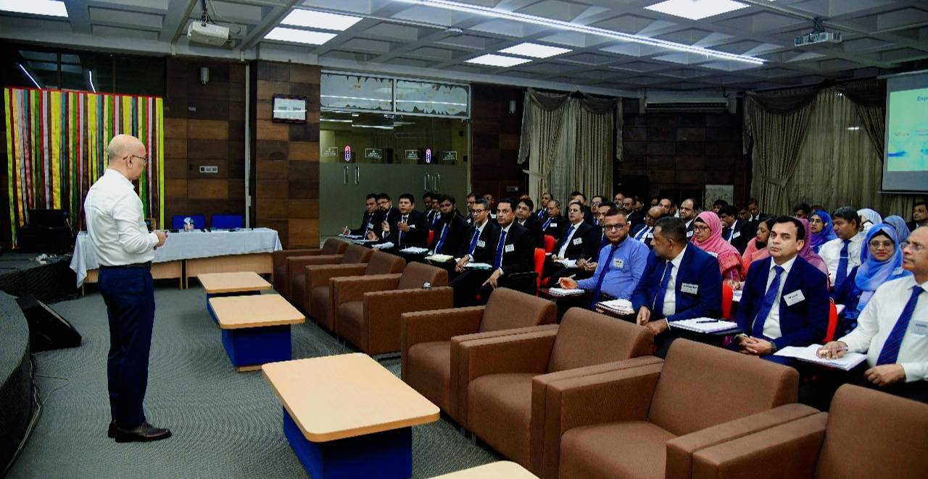
Mr. Md. Sayeedul Haque, Chief (Retd.), Planning Division, conducted a thought-provoking session for the 13th SFTC (ECS) titled “Project Appraisal to Monitoring & Evaluation: Understanding Critical Issues” on 4 November 2025,.
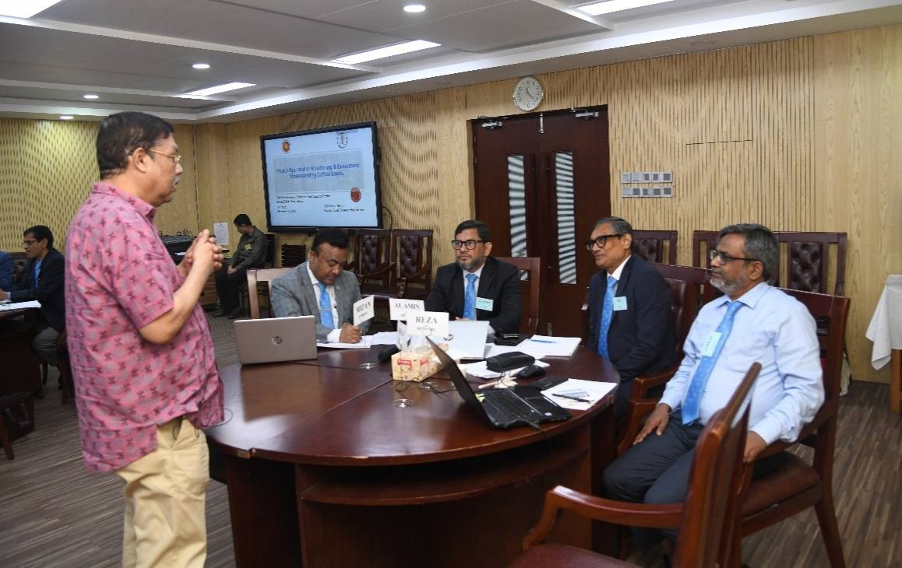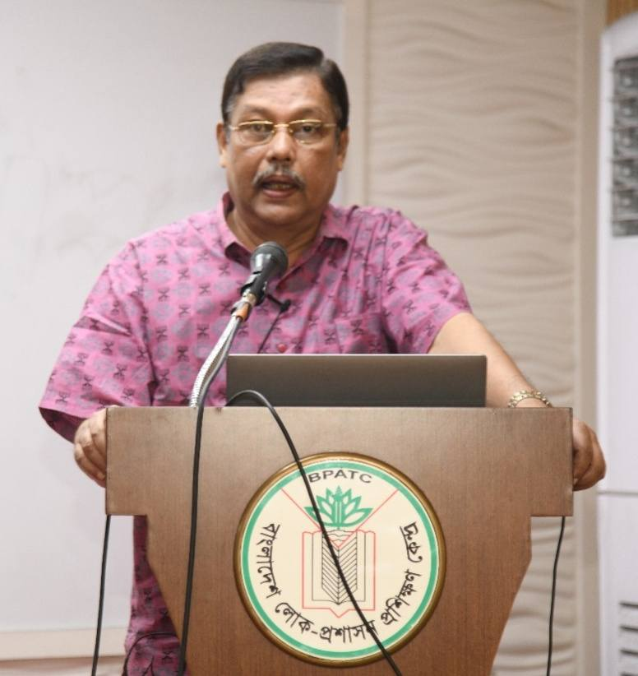
Mr. Md. Shamimul Haque, Additional Secretary, Ministry of Industries, conducted a strategic session on “DPP Preparation & Log Frame” for the 154th ACAD On 3 November 2025.
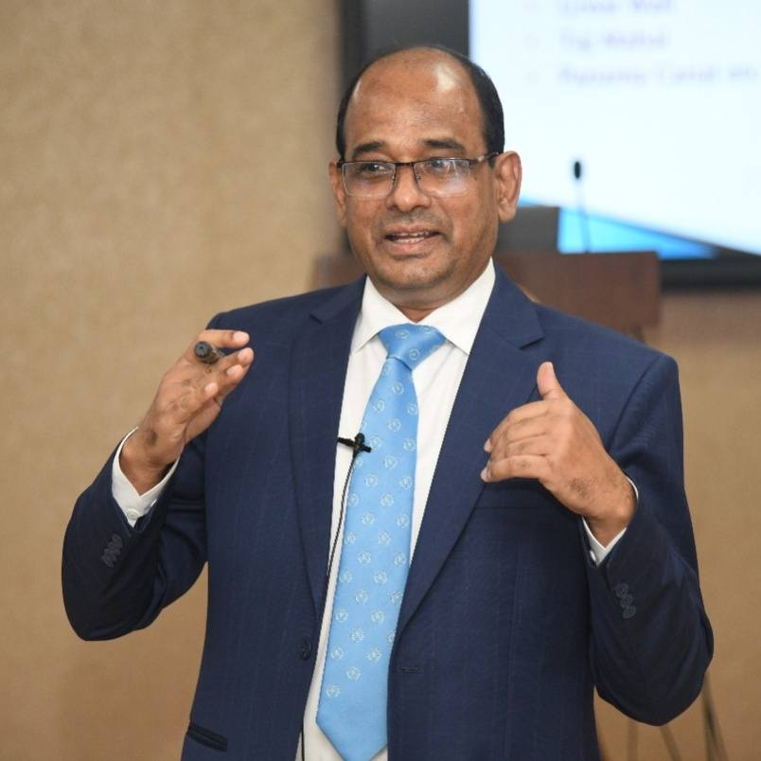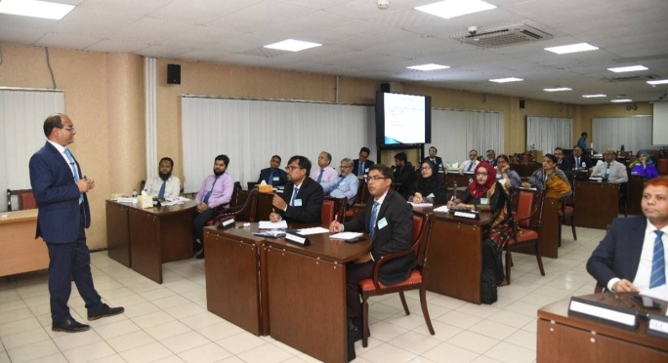
Industrial Visit: As part of the training. Participants of 28th PPMC undertook an industrial exposure visit to Akij Ceramics Limited on October 30.
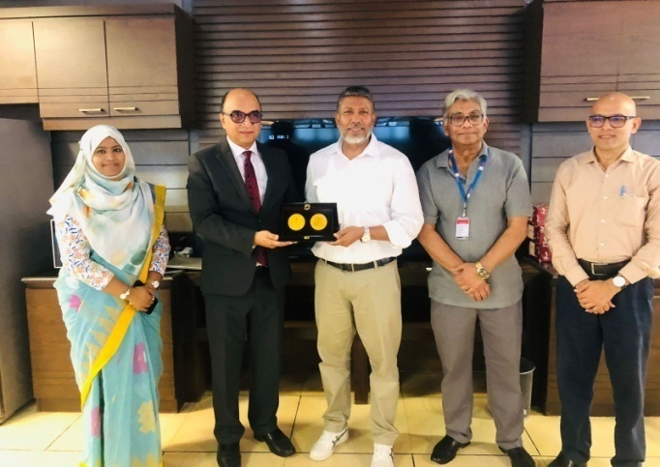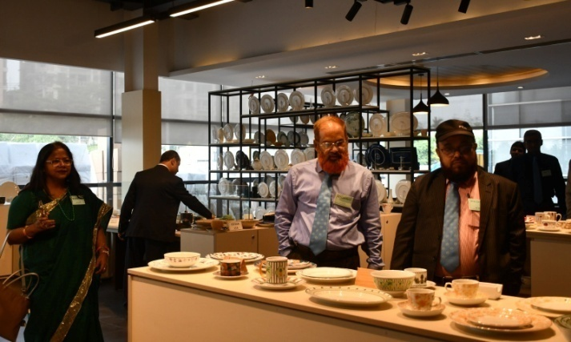
Brig. Gen. Abul Fazal Md. Sanaullah (Retd.), Election Commissioner, conducted a session for the 13th SFTC (ECS) on “Conducting Elections: Procedures and Steps (OCV and ICPV) & Voter Registration Management: Bangladesh Context and Abroad” on 5 November 2025.
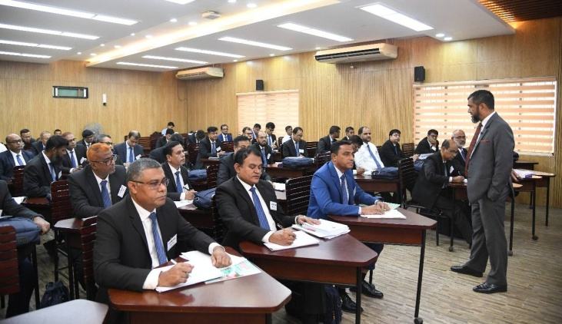
Mr. K. M. Ali Newaz, Additional Secretary, ECS, led an insightful session for the 13th SFTC (ECS) on “Conducting Elections: Procedures and Steps – OCV and ICPV” on 4 November 2025.
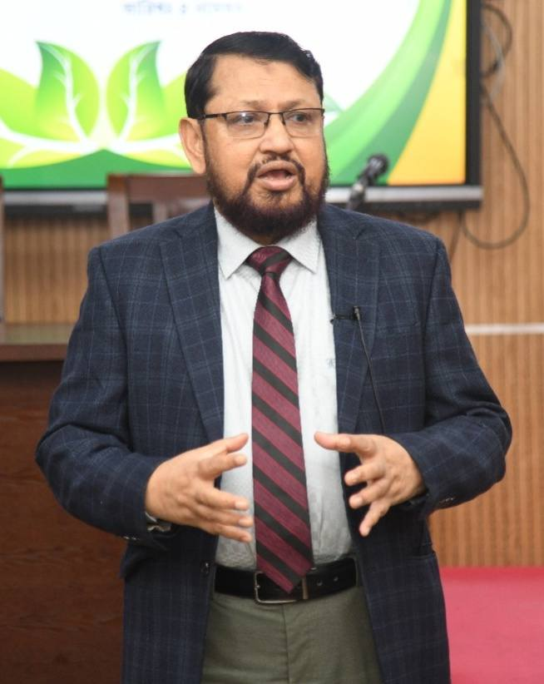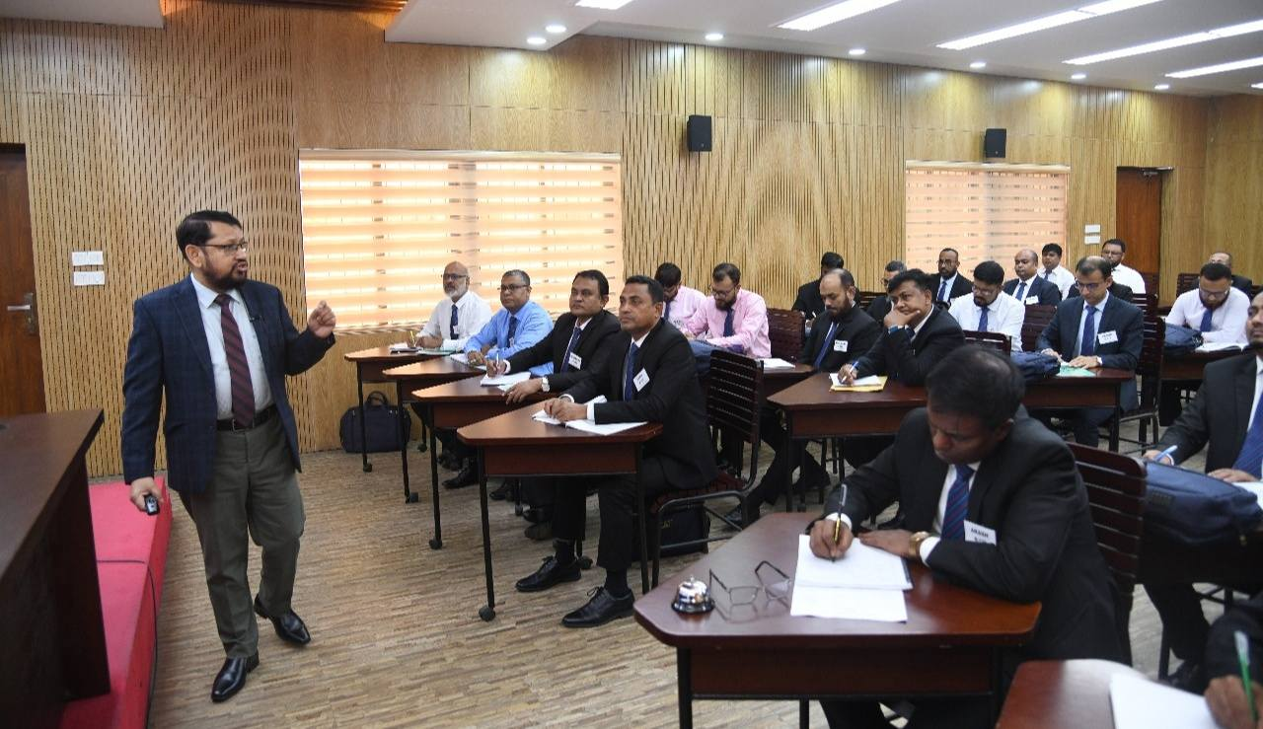
Dr. Md. Mahmudur Hassan, Chairman (Grade-1), Land Appeal Board, delivered an enlightening session for the 78th FTC on “Sairat Mahal Management and Record Updating” on 1 November 2025.
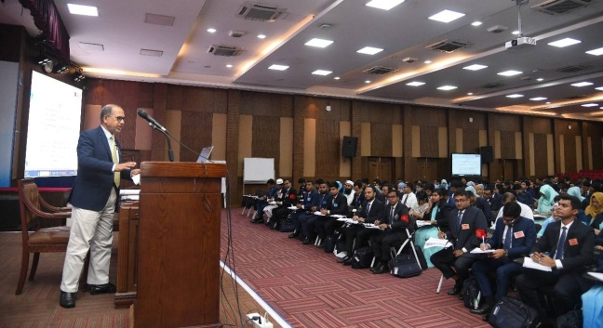
Ms. Afroza Parvin, Deputy Secretary, BPPA, IMED, conducted a deeply insightful session on Request for Quotation Method (RFQM) for the 13th SFTC on 6 November 2025.
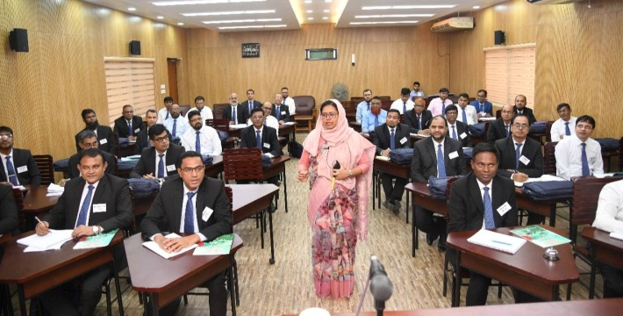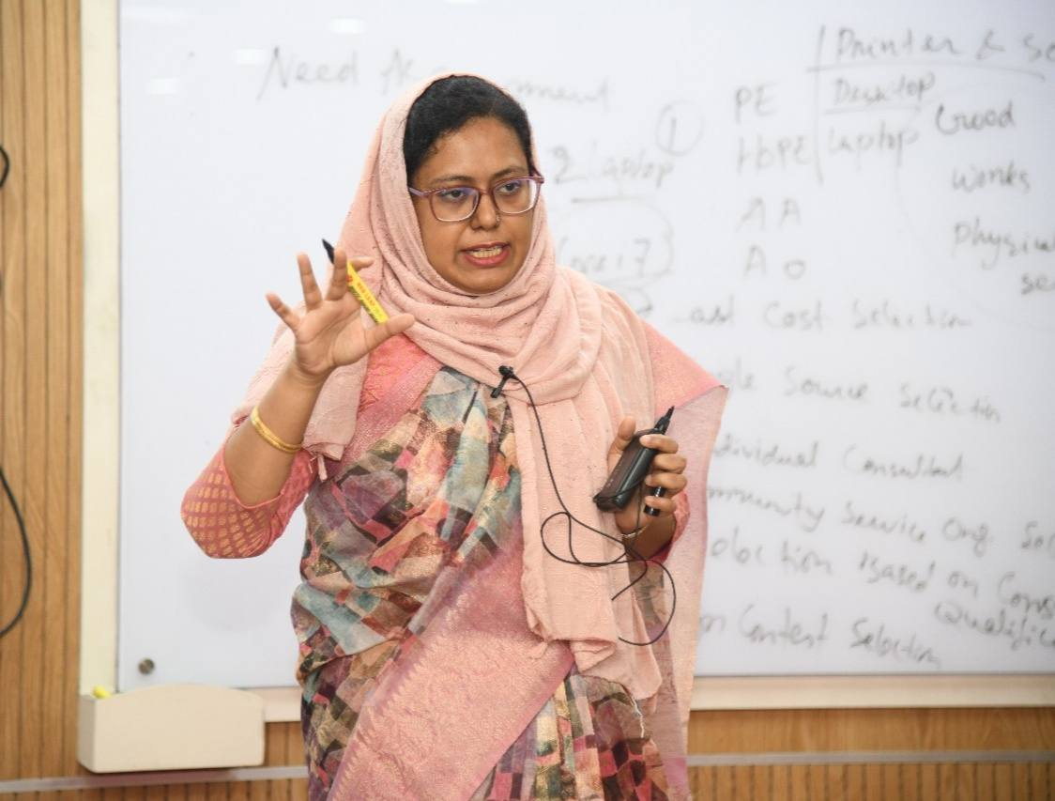
Mr. Muhammad Munir Chowdhury, former DG of the National Museum of Science and Technology, led a session on “Promoting Ethics and Integrity in Organizations: International Best Practices in Combating Corruption” for the 1st ACPD participants on 10 November 2025.
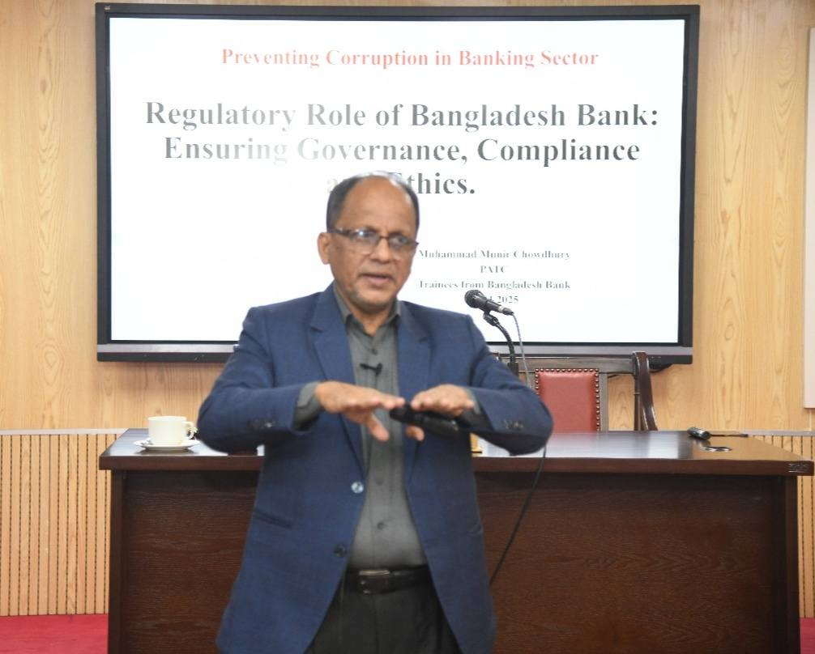
Dr. M. Aslam Alam, Former Rector, BPATC, conducted a session on the “Behavioral Drivers of Performance and Motivation for Organizational Productivity” for the 1st ACPD participants.
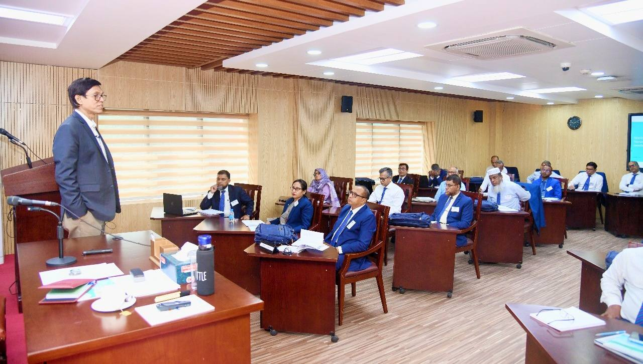
Dr. Nazneen Kawshar Chowdhury, Executive Chairperson, National Skills Development Authority, presented a discussion on “Skill Development & Negotiation Strategy” for the 28th PPMC on 5 November 2025.
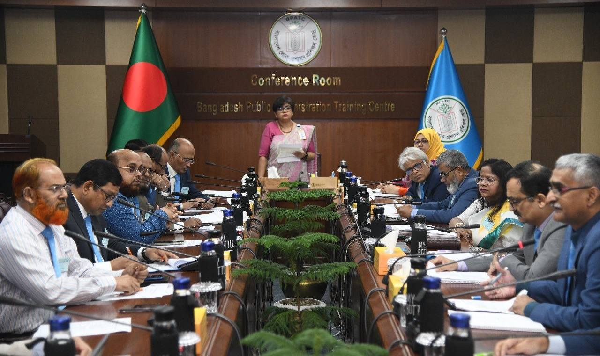
Professor Mohammad Azam, DG, Bangla Academy, conducted a session for the 78th FTC on the evolution and significance of Bangladeshi Literature on 15 November 2025.
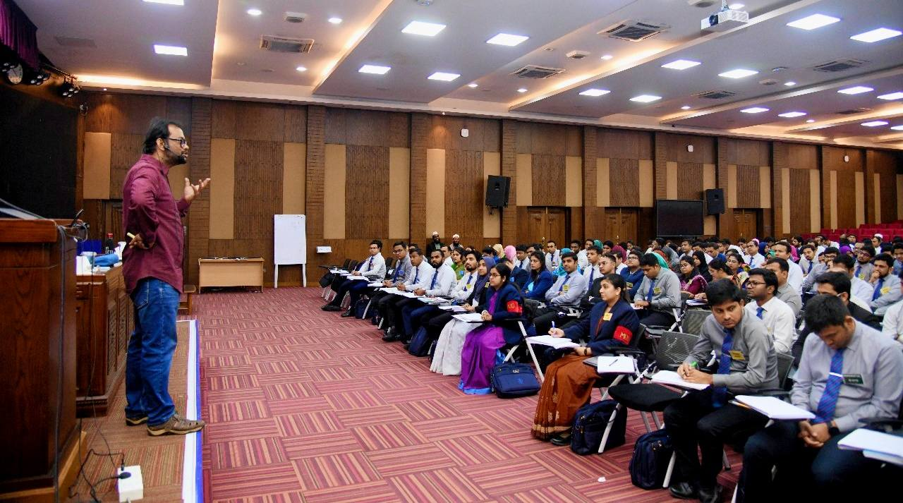
Dr. Shafiqul Islam, Deputy Secretary, RPATC, led a session on “Basics of Data Analysis and Interpretation: Qualitative Data” for the 78th on 12 November.
Dr. Moniruzzaman, Coordinator & Expert in Lifestyle Modification, Quantum Heart Club, conducted a special session on “Scientific Lifestyle and Food Habit” for the 120th SSC participants on 12 November 2025.
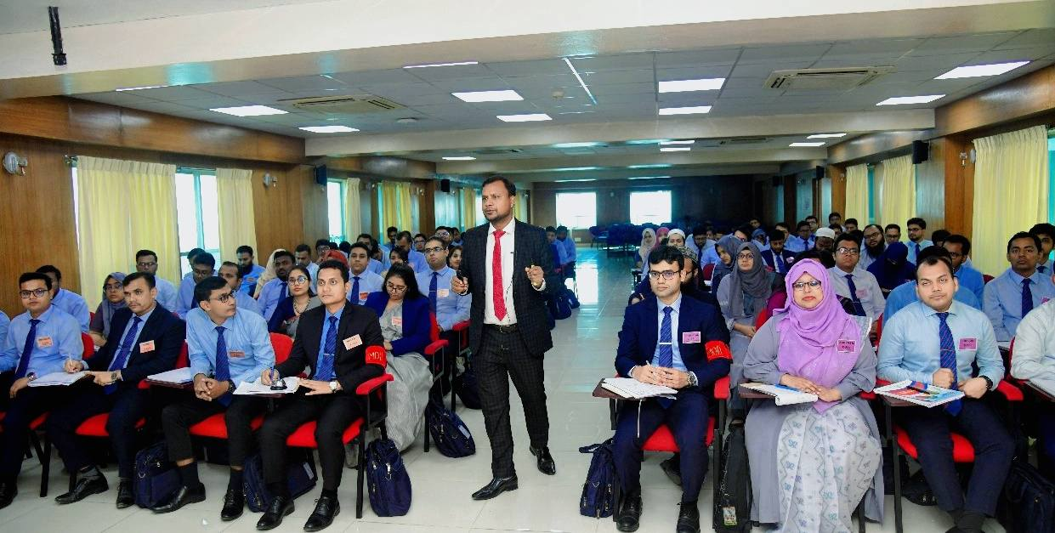
Mr. Md. Abu Bakar Siddique, Vice-Chairman (Grade-1, Retd.), BTRC, delivered a session on “Stress Management and Strategies for Ensuring Work-Life Balance” for the 154th ACAD on 6 November 2025.
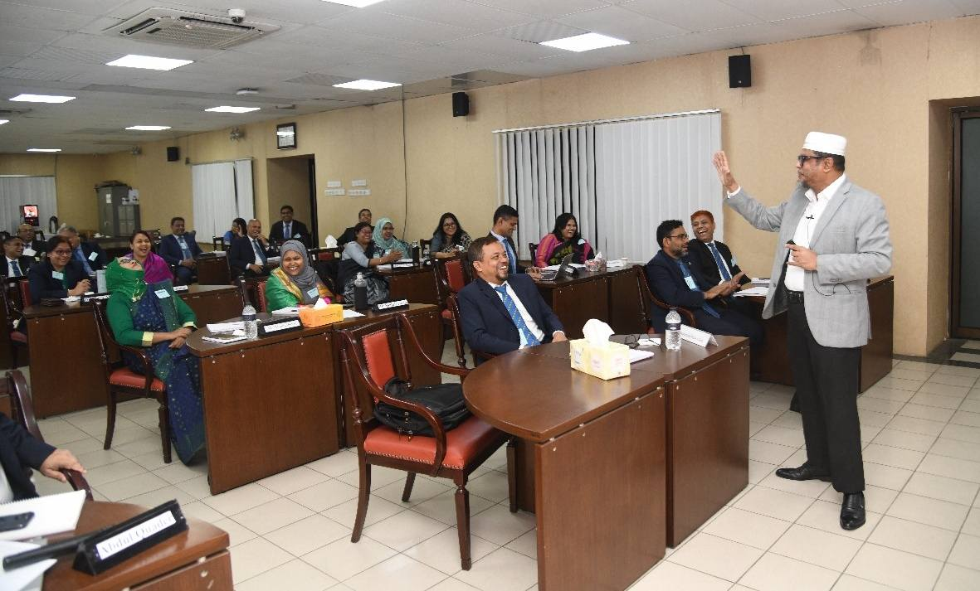
Ms. Nasreen Jahan, Secretary, Ministry of Civil Aviation and Tourism, conducted an insightful session for the 28th PPMC titled “Employment, Productive Inclusion & Remittance System” on 3 November 2025.
